“Expert Cloud Consulting” -

Server Migration
19. February .2025
Version 1.0
─
Contributed by Prasad Bandagale
Approved by (In review)
Expert Cloud Consulting
Office #811, Gera Imperium Rise,
Hinjewadi Phase-II Rd, Pune, India – 411057

“Expert Cloud Consulting”
Server Migration

1.0 Contents
1.0 Contents 2
2.0 General Information: 3
2.1 Document / GitHub URL(s) 3
2.2 Document Purpose 3
2.3 Document Revisions 3
2.4 Document References 3
3.0 Prerequisite: 3
3.1 Virtual machine 3
3.2 Required Software 4
4.0 Document Overview: 6
5.0 Application Components Documentation 7
5.1 Overall Application Architecture 7
5.2 Frontend Component (React.js) 7
5.3 Backend Component (Flask) 8
5.4 Database (PostgreSQL) 9
5.5 Deployment Considerations 9
6.0 Implementation Details 9
6.1 Docker Implementation 9
6.2 Kubernetes Manifests 11
6.3 Deployment Steps 12
6.4 Monitoring and Scaling 14
6.0 Testing and Verification: 15
6.1 Live Application 15
6.2 Load Testing Procedure 16
7. Troubleshooting Guide: 19
7.1 Common Issues 19
8.0 Conclusion: 19
8.1 Key Achievements: 19
8.2 Primary Benefits: 19
8.3 Recommendations 19

2.0 General Information:

2.1 Document / GitHub URL(s)

Ticket(s) Name | URL
Kubernetes Fundamentals | https://github.com/Prasad-b-git/Weekly-task/tree/main/06-02-2025

2.2 Document Purpose
This technical documentation outlines the complete process of migrating AWS instances to Azure Virtual Machines using Azure Migration Services, including the setup, execution, and best practices.

2.3 Document Revisions

Date | Version | Contributor(s) | Approver(s) | Section(s) | Change(s)
17/01/25 | 1.0 | Prasad Bandagale | In Review | All Sections | New Document Created

2.4 Document References

Date | Document | Filename / URL
2024 | Azure Migrate Documentation | https://docs.microsoft.com/en-us/azure/migrate/
2024 | Azure Virtual Machines | https://docs.microsoft.com/en-us/azure/virtual-machines/
2024 | Kind Documentation | https://kind.sigs.k8s.io/docs/user/quick-start/

3.0 Infrastructure Overview

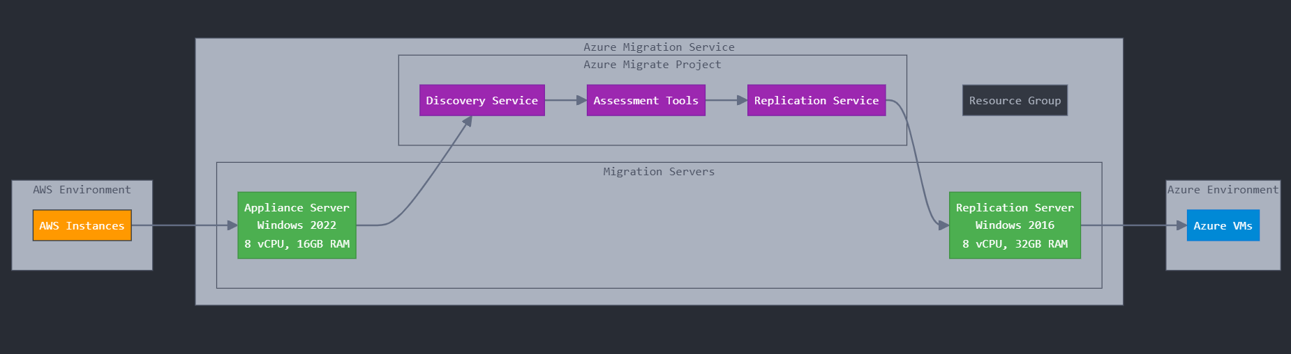

3.1 Source Environment (AWS)
Details of AWS instances being migrated:
- Instance specifications and configurations
- Operating systems
- Storage configurations
- Network settings

3.2 Target Environment (Azure)

3.2.1 Appliance Server
- Operating System: Windows Server 2022
- Specifications:
  - CPU: 8 vCPU
  - RAM: 16 GB
  - Storage: 80 GB
- Role: Hosts migration tools and services

3.2.2 Replication Server
- Operating System: Windows Server 2016
- Specifications:
  - CPU: 8 vCPU
  - RAM: 32 GB
  - Storage: 300 GB
- Role: Manages data replication to Azure

4.0 Migration Components

4.1 Azure Resources
- Resource Group
  - Created as primary container
  - Houses all migration-related resources
  - Enables centralized management

- Azure Migrate Project
  - Assessment capabilities
  - Discovery features
  - Migration tracking
  - Performance monitoring

5.0 Migration Process

5.1 Pre-migration Phase

1. Resource Group Creation
- Name selection
- Region selection
- Tag configuration
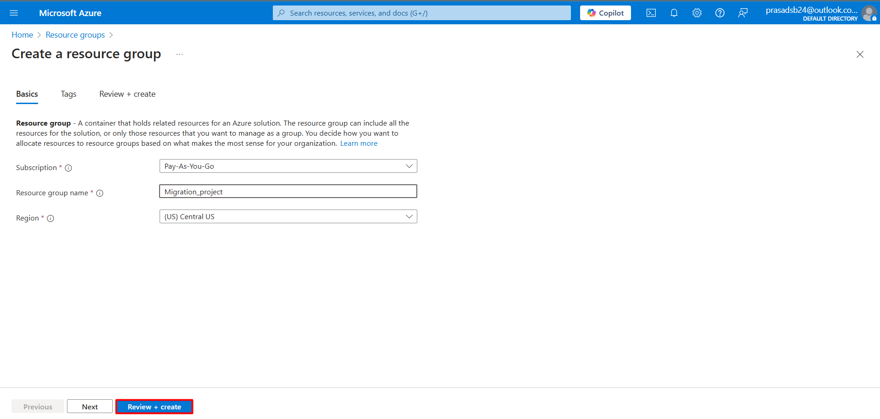

2. Azure Migrate Project Setup
- Project configuration
- Tool selection
- Discovery setup
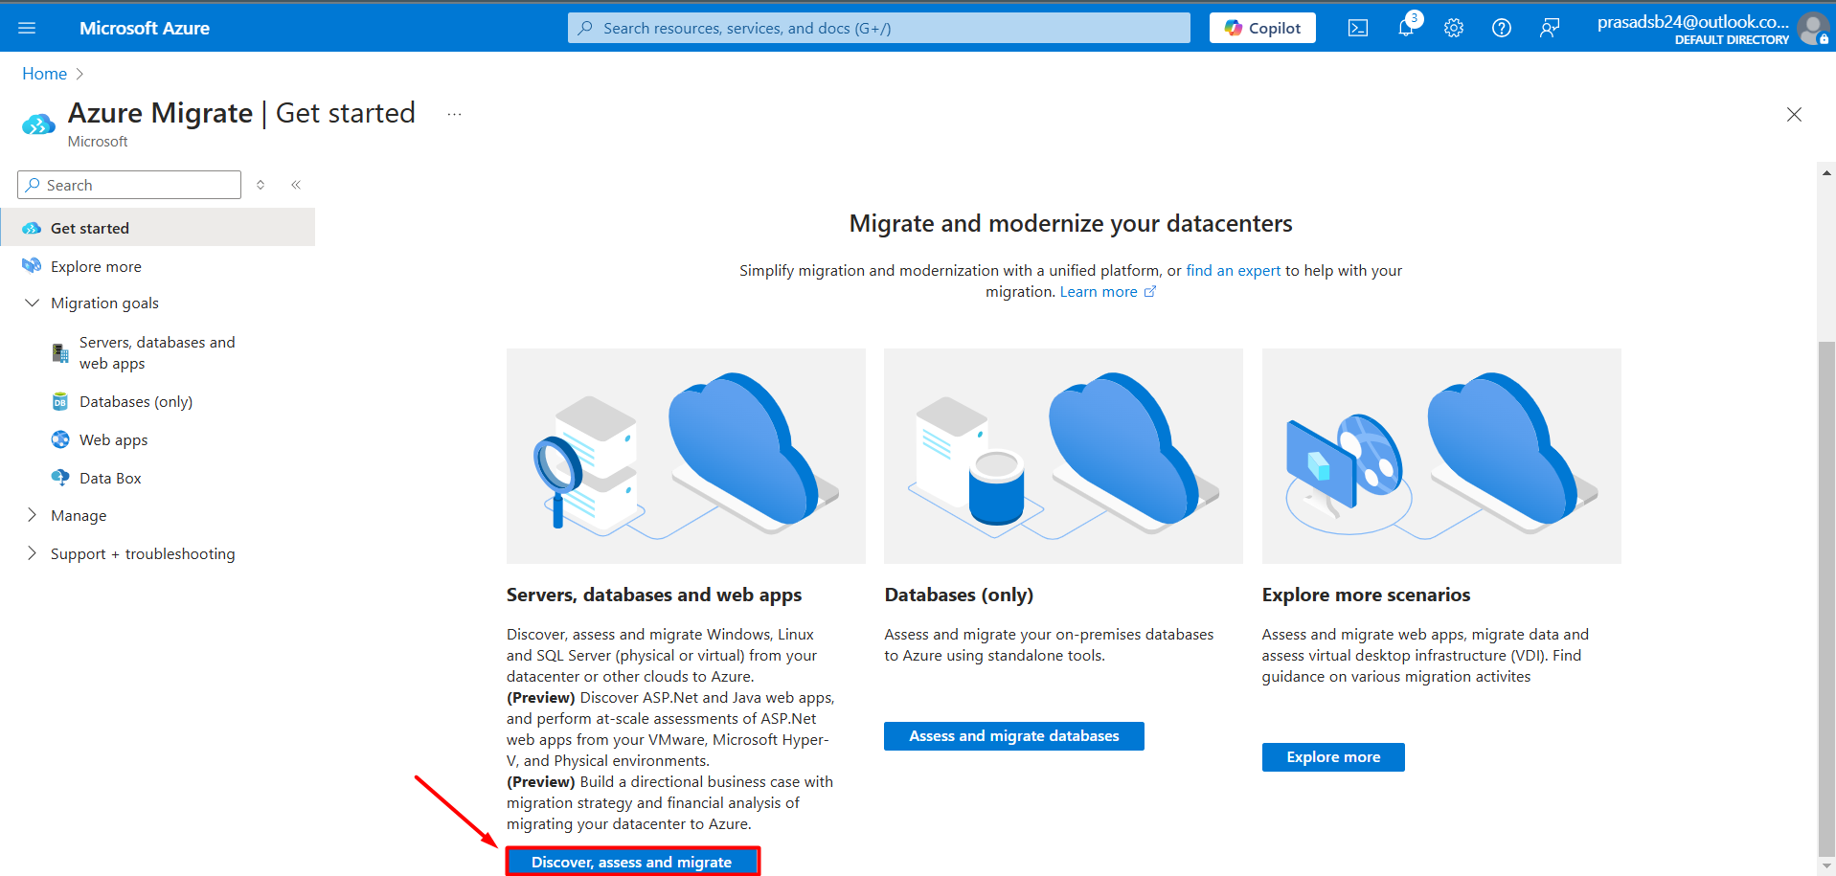

Step 1: Create project in Azure Migrate service.

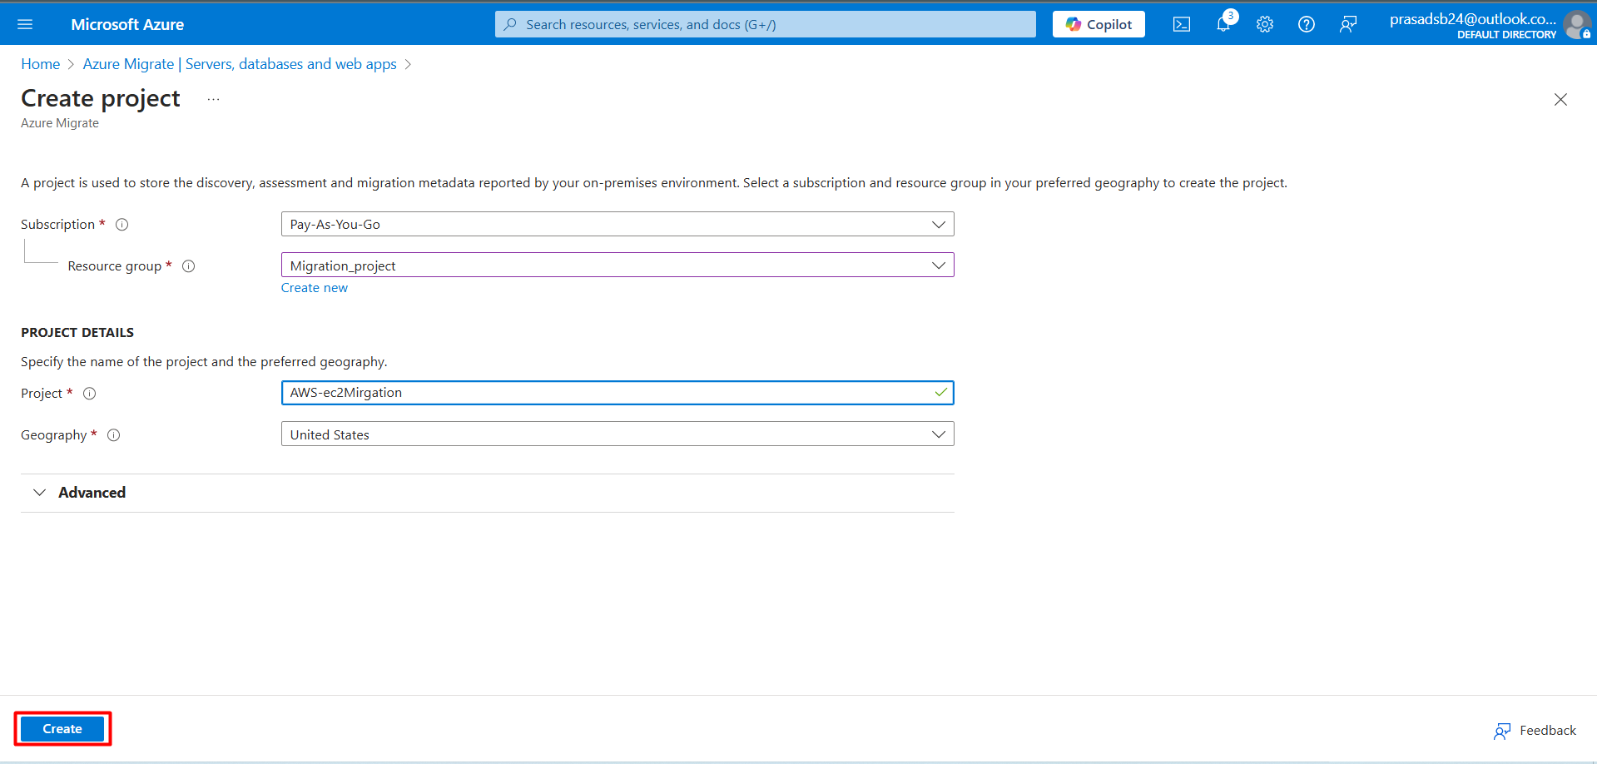

Step 2 : Click on discover using appliance
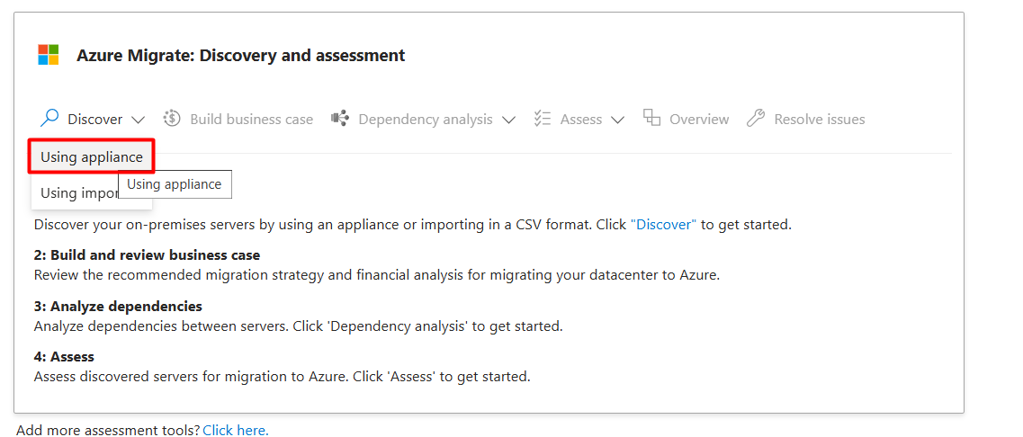

Step 3: Select physical or other and Generate the key

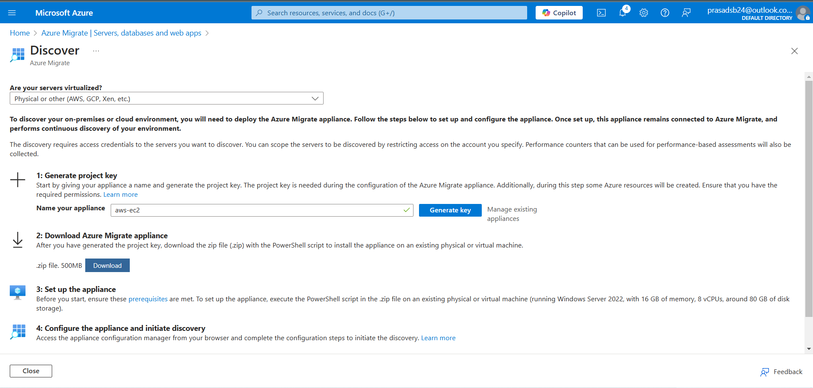

5.2 Setup Phase

1. Appliance Server Configuration
- Windows Server 2022 setup
- Azure tools installation
- Network configuration
Step 1: Connect the appliance server using RDP and Download AzureMigrateInstaller.zip. Then Unzip the AzureMigrateInstaller.
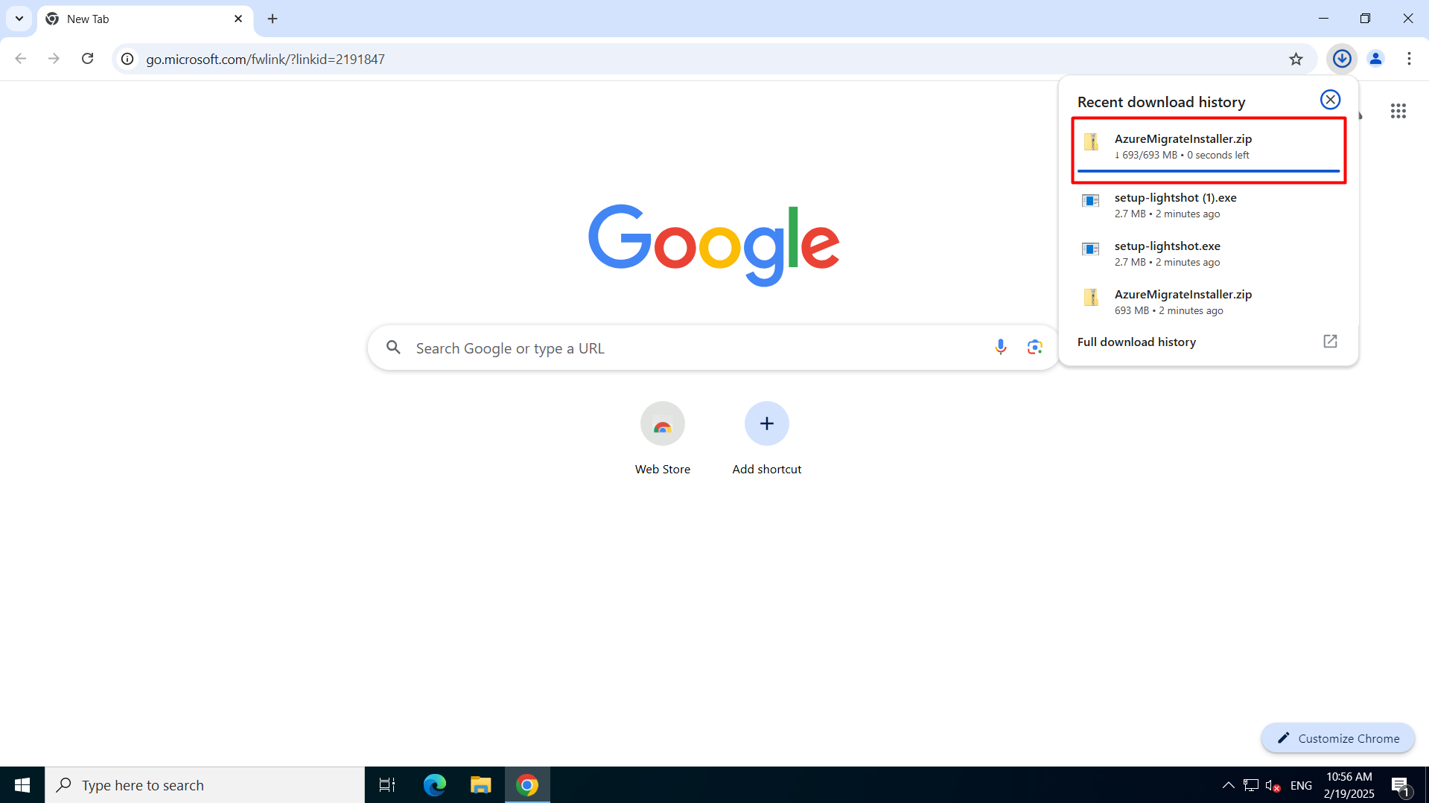

Step 2: Now open PowerShell using Administrator, then open the AzureMigrateInstaller script in PowerShell.
This is install azuremigrate.
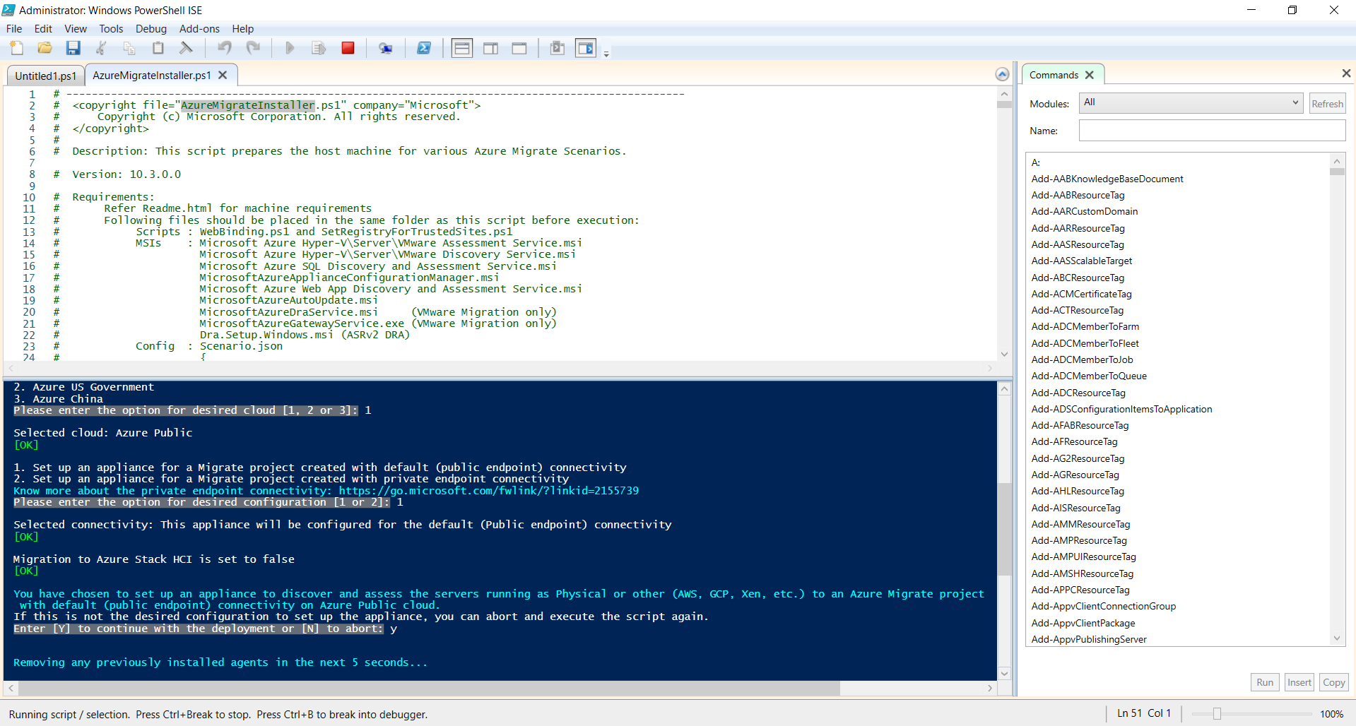

Step 3: Now open the Appliance Configuration Manager.
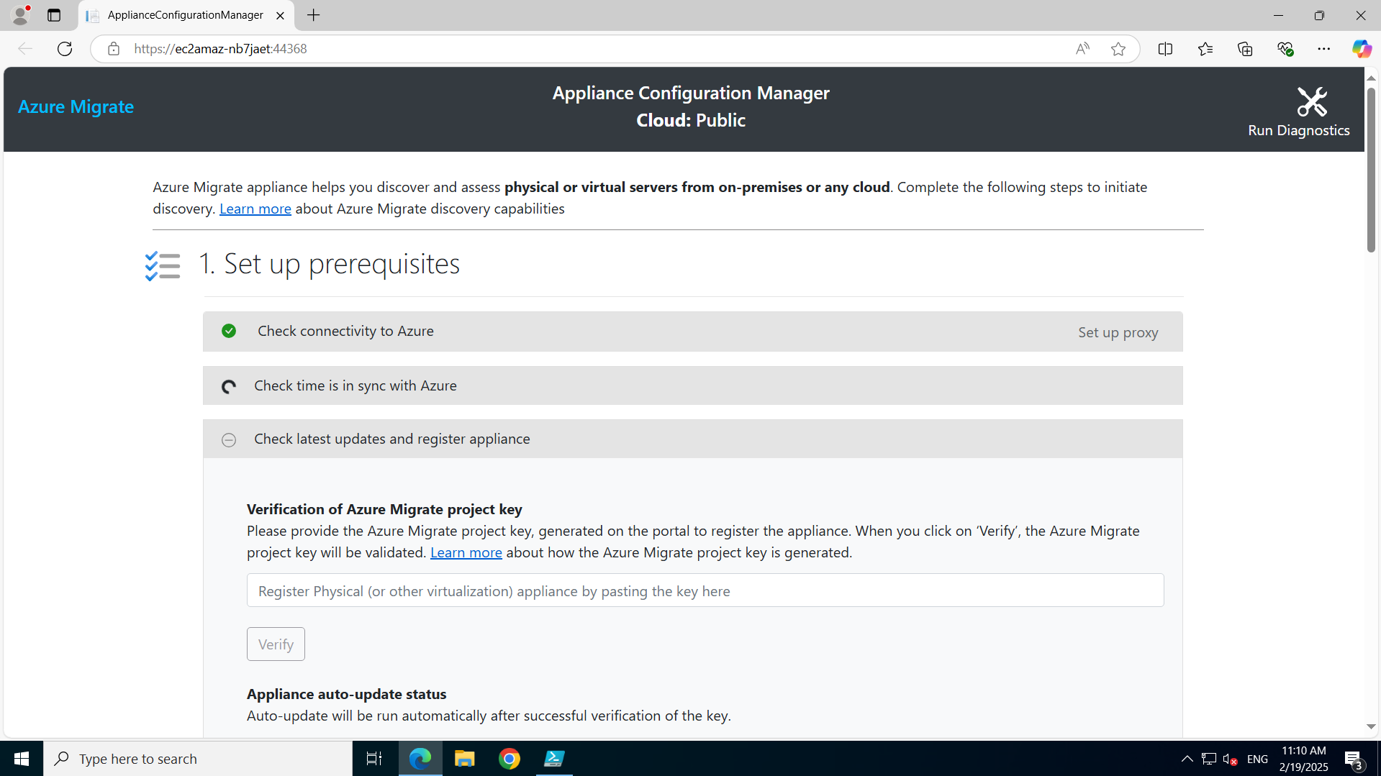

Step 4: Verify Appliance Configuration Manager with project key. This will Auto-Update the Appliance and then login Azure account with copied code.
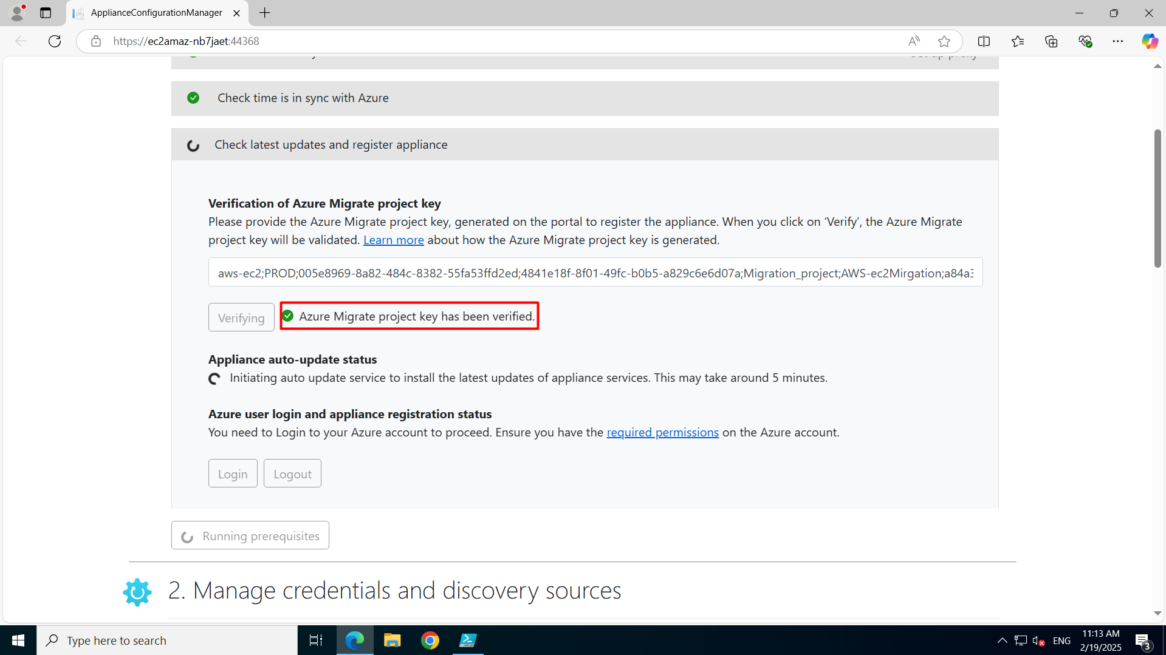
Step 5: Login will start initialling appliance registration and could take 10-15 mins to complete.
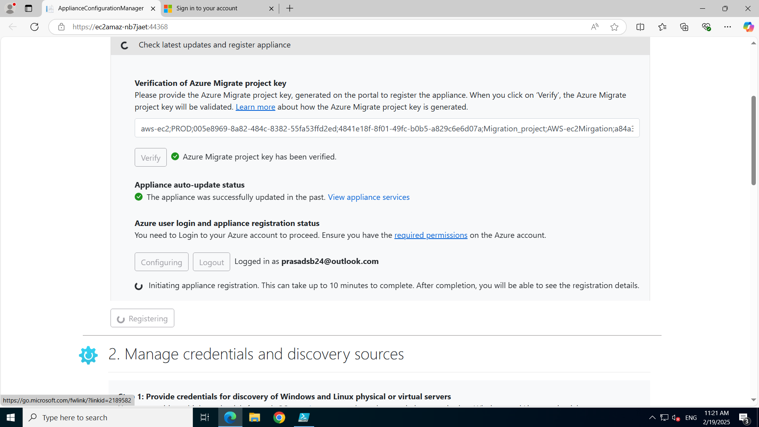
Step 6:Add the credentials of sources server.
Friendly Name could be any. Then Add username and Password of source server.
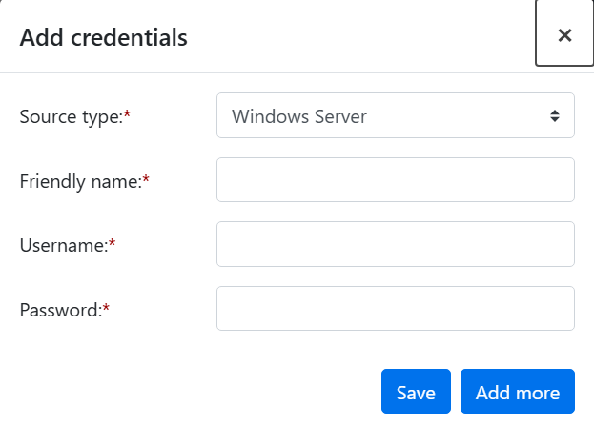
Step 7: Then add source server for discovery with private IP of the server. (Note: Keep the 5985 port open of the instance to connect with appliance server.)
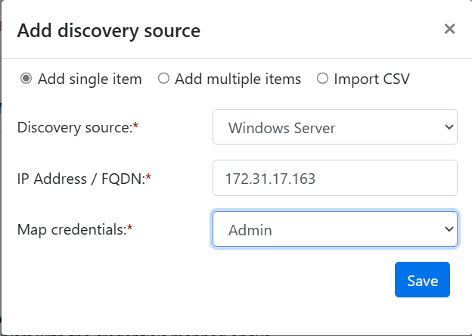
Step 8: Now click on start Discovery, which will discover the instance at azure portal. This will Initiate discovery and it could take 5-10 mins to complete.
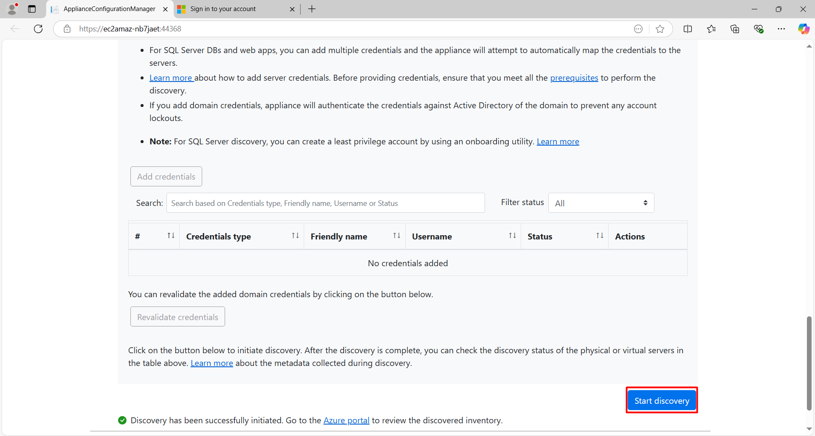

Step 9: Check the Azure Migrate and then refresh the service to check if any server is discovered or not.
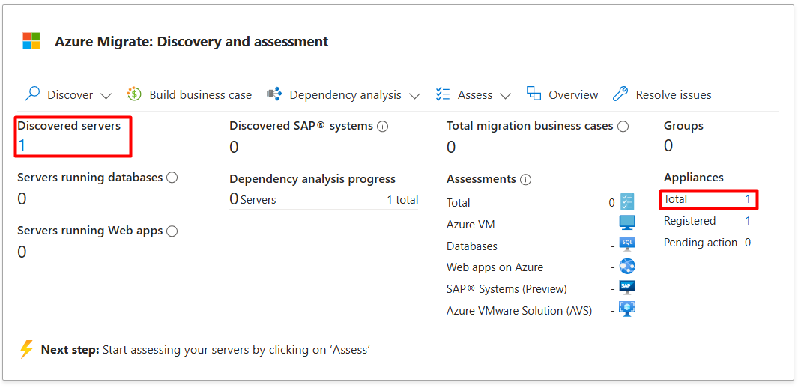
Step 10: Now Create the Assessment for the server. If required change the assessment setting.
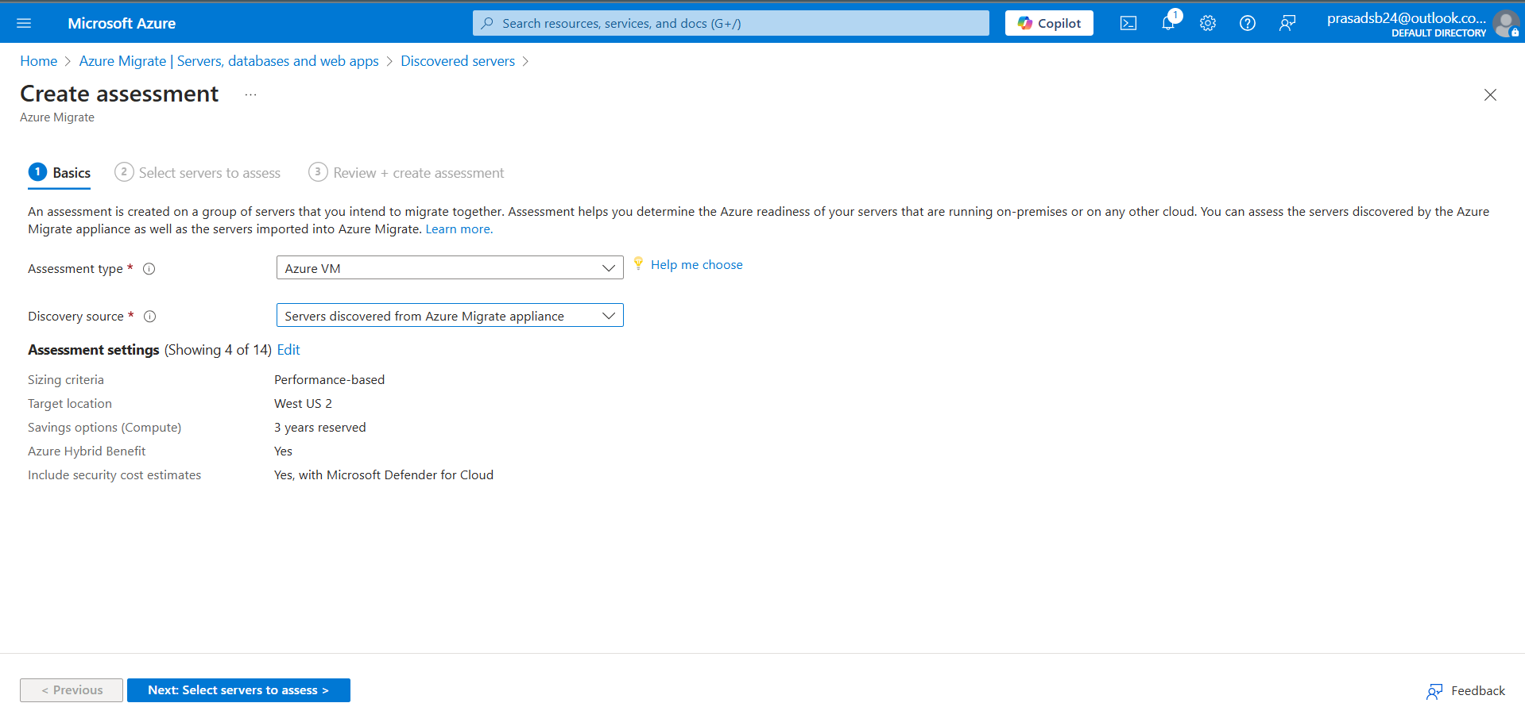
Step 11 : Then name the assessment and group of the assessment, then select the server. Then refresh and check the group is created or not.
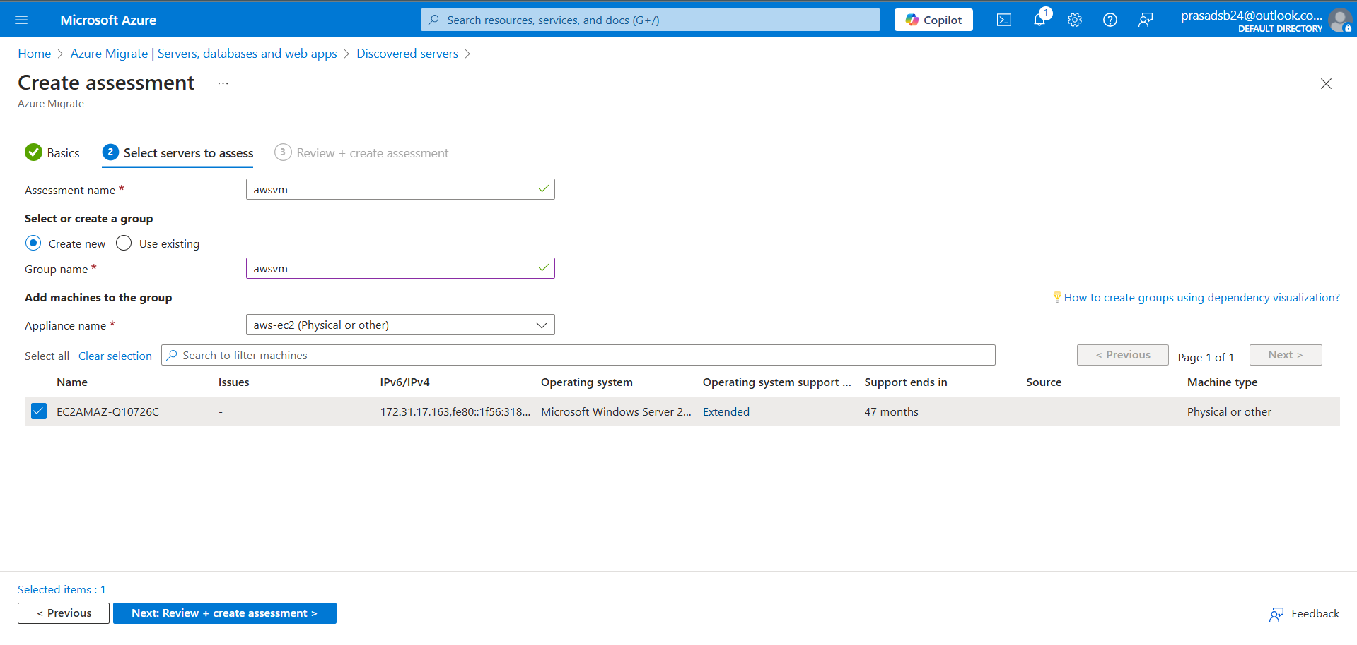
2. Replication Server Setup
- Windows Server 2016 setup
- Storage configuration
- Network settings
Steps 1: Click on Discover in Migration tools.
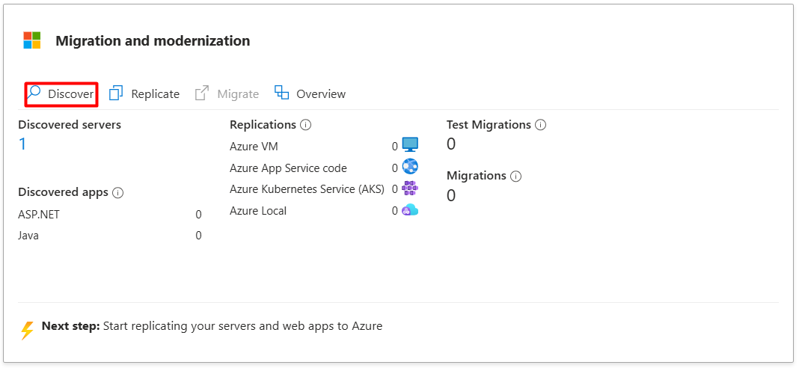
Step 2: Create the migration tool resource
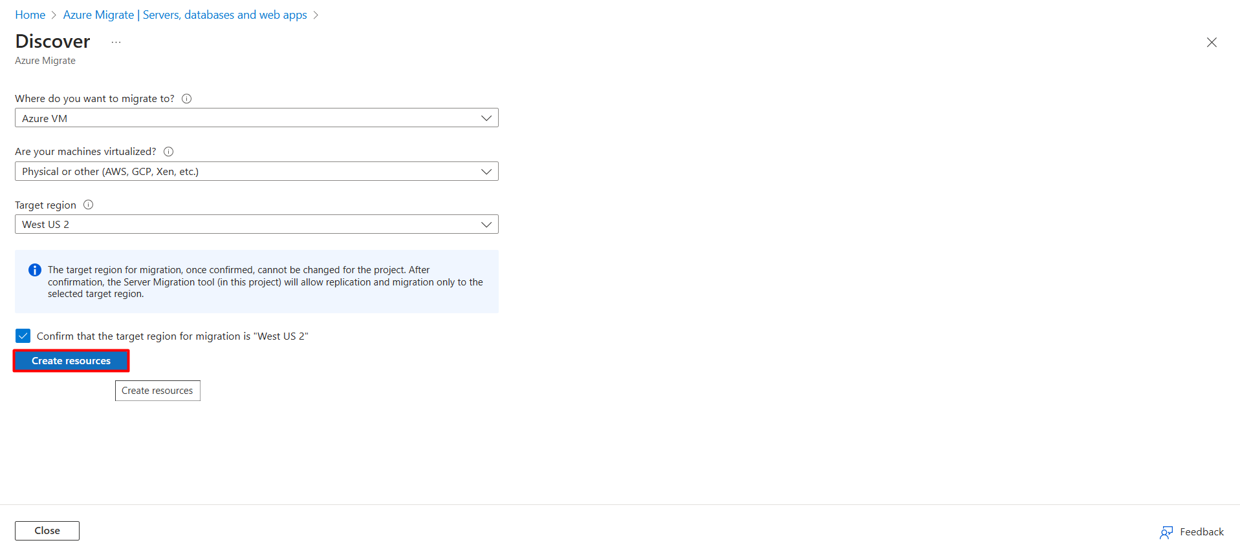
Step 3 : Then Follow this 2 steps and RDP the replication Server. Then download the MicrosoftAzureSiteRecoveryUnifiedSetup. Then run the setup.
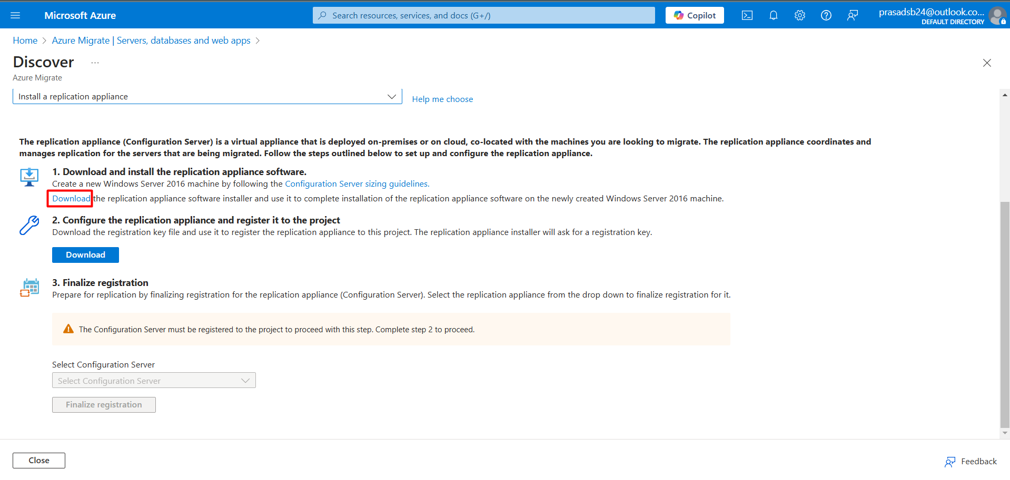
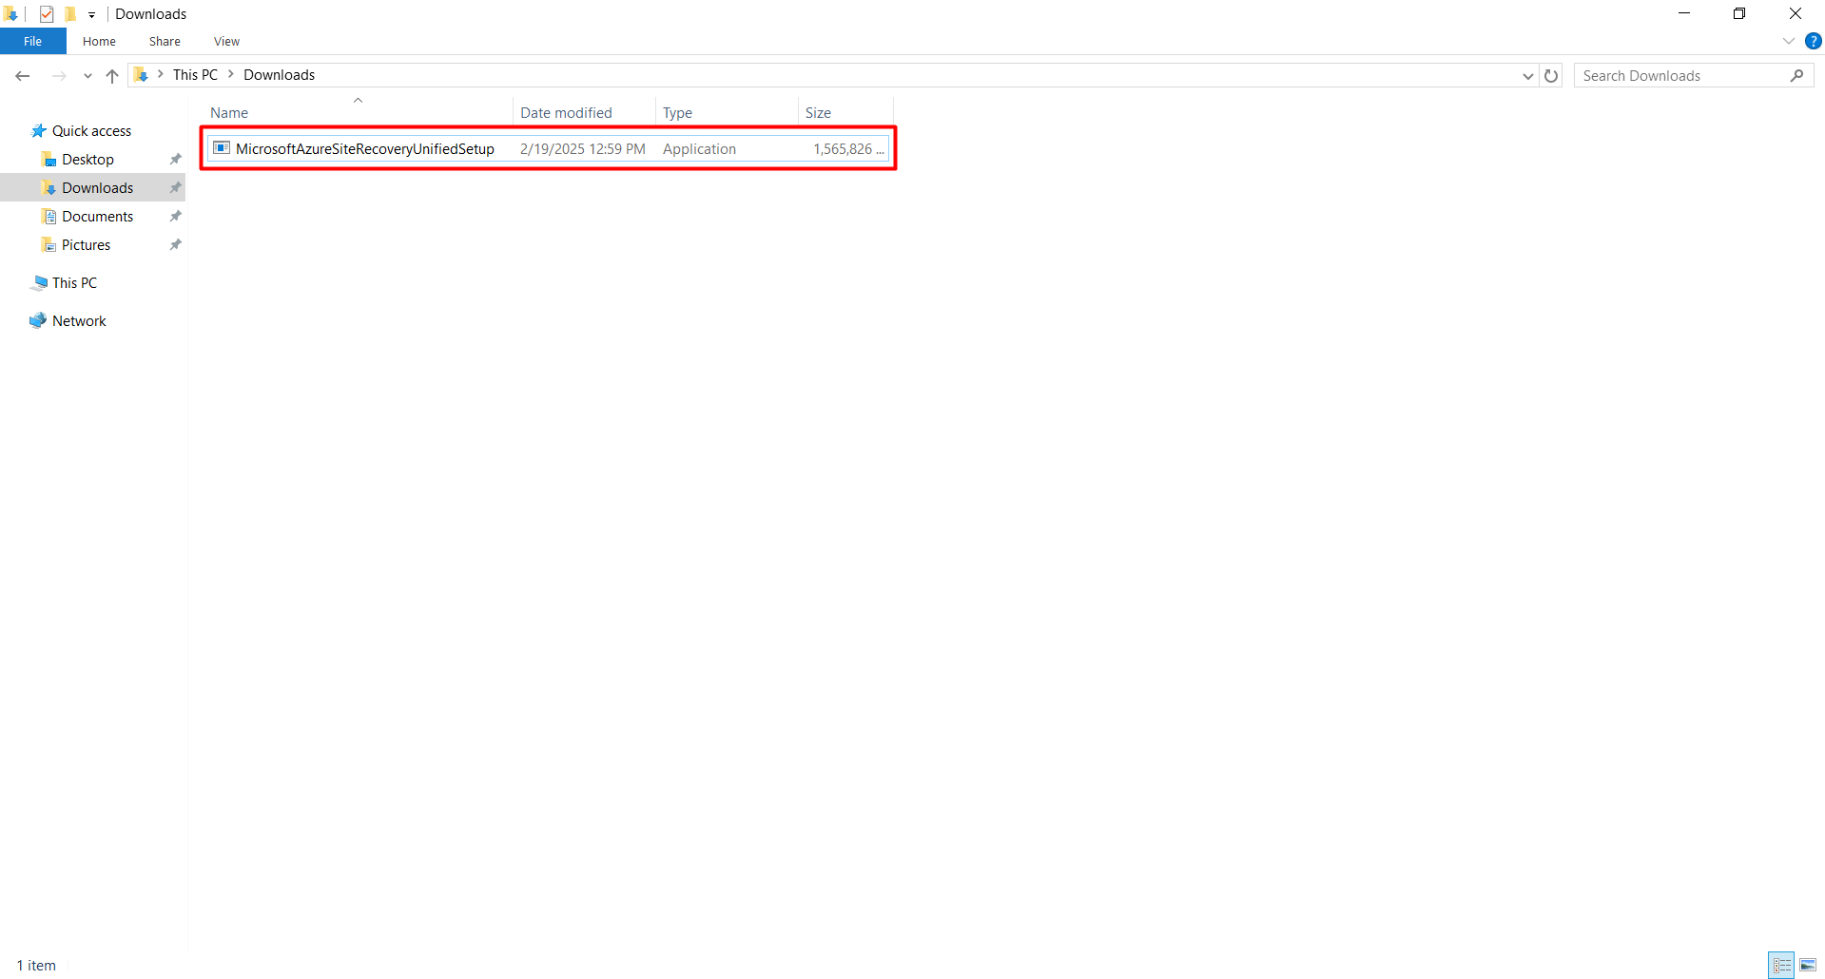
Step 4: Select the option of “install the configuration server and process server” and follow up with next for third party sotware license.
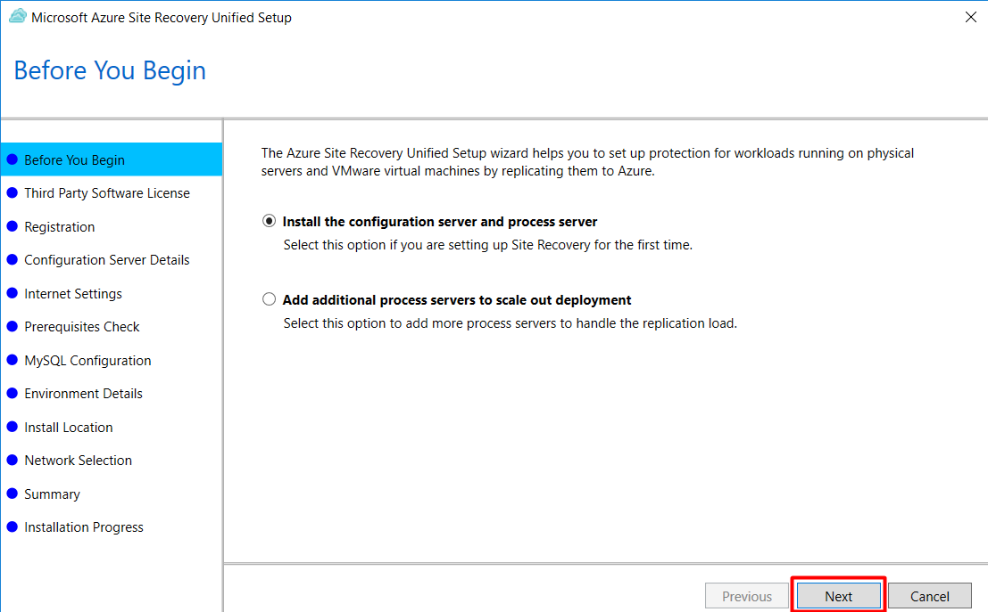
Step 5: Now download registration key in your replication server.
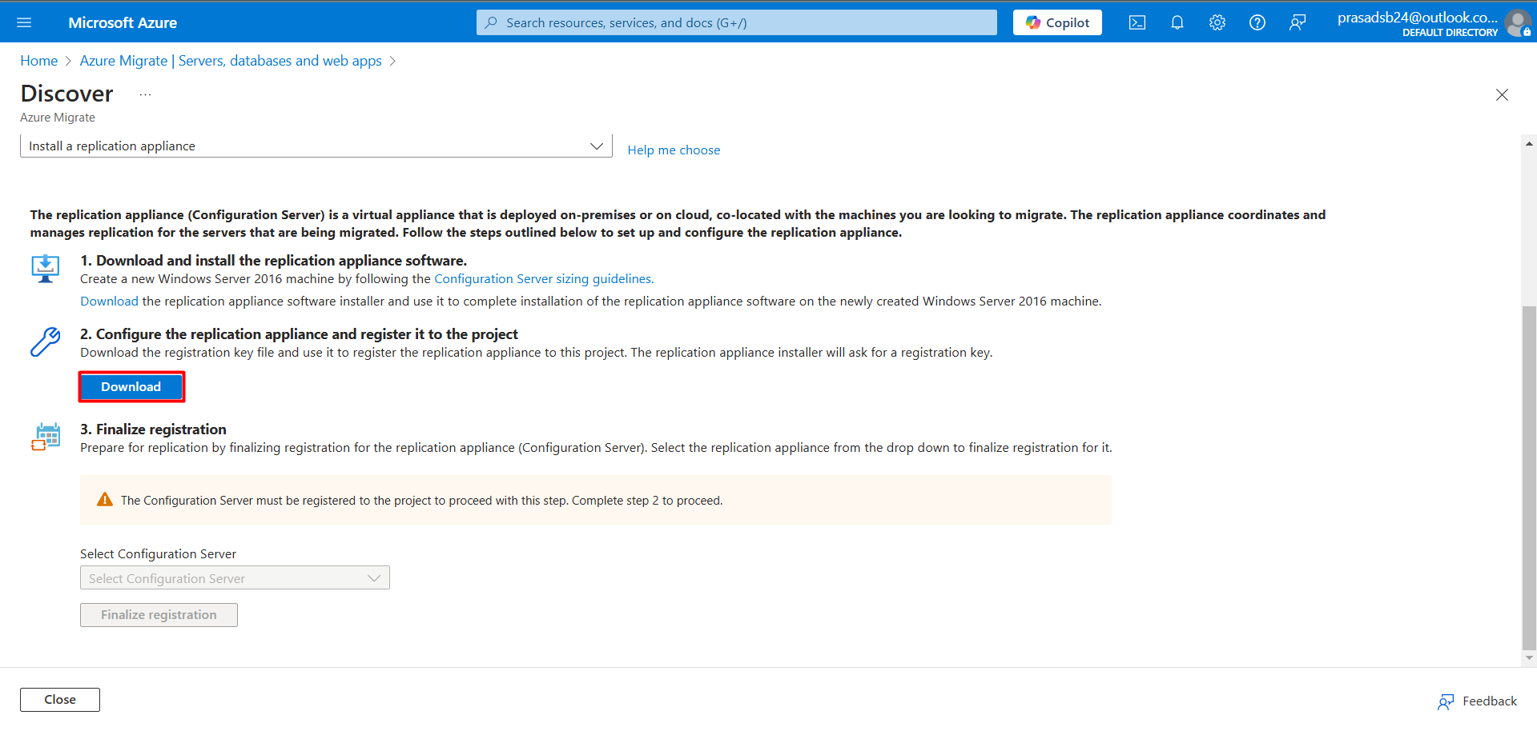
Step 6: Now browse that key in Registration and select next.
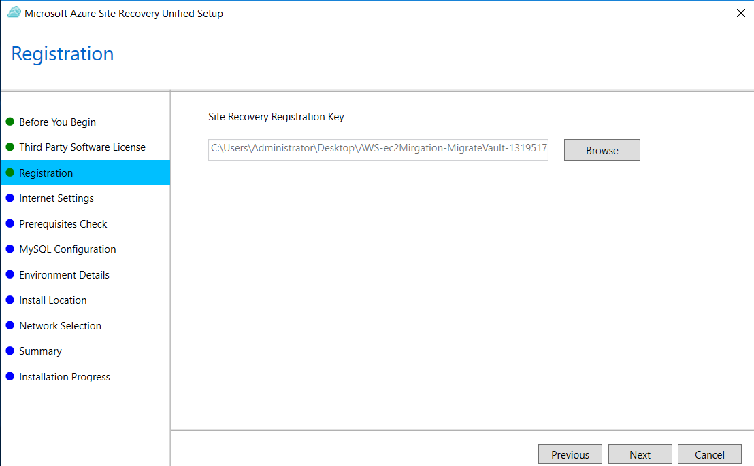
Step 7: Keep Internet setting default if you are not using proxy server. Next, it will check the server configuration.
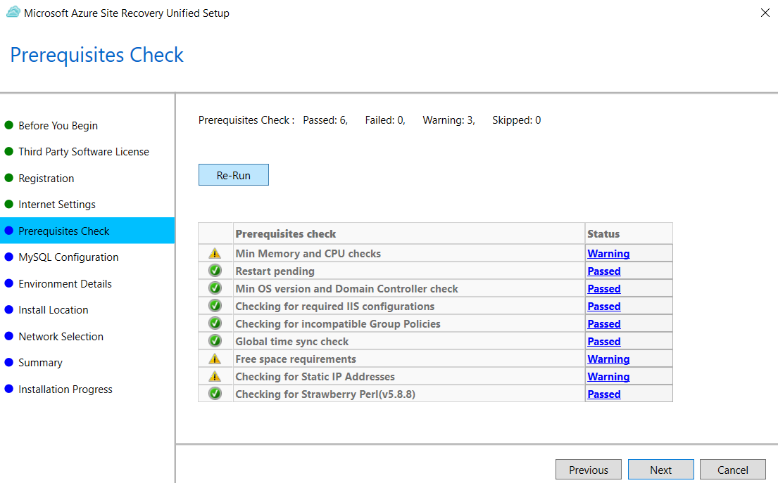
Step 8: Configuration the MySQL Database with password.
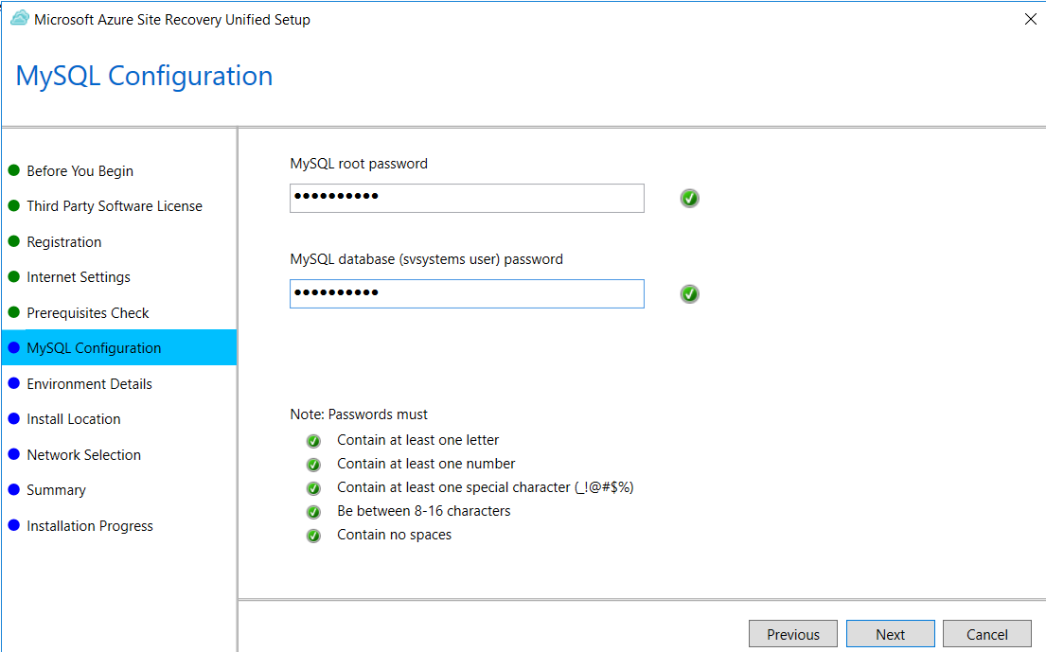
Step 9: Keep this as NO if you don’t want protect VMware virtual machines.
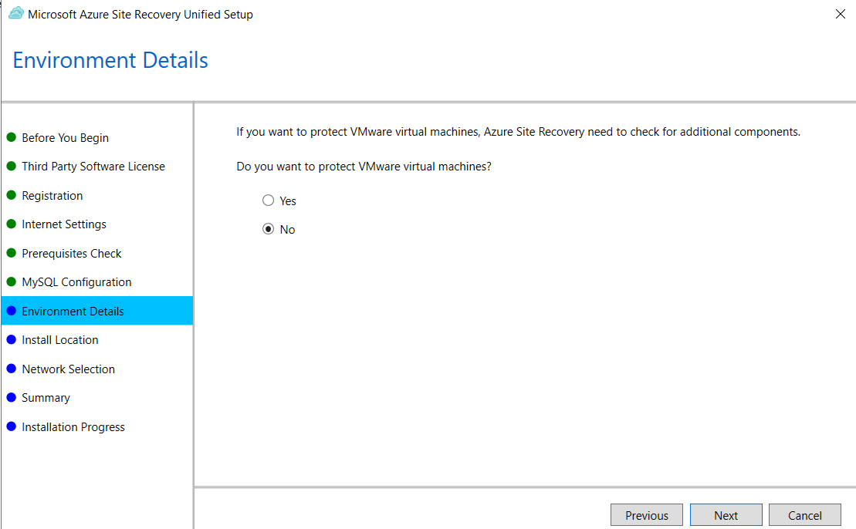
Step 10: Select the network interface as Ethernet 3 for smooth connection.
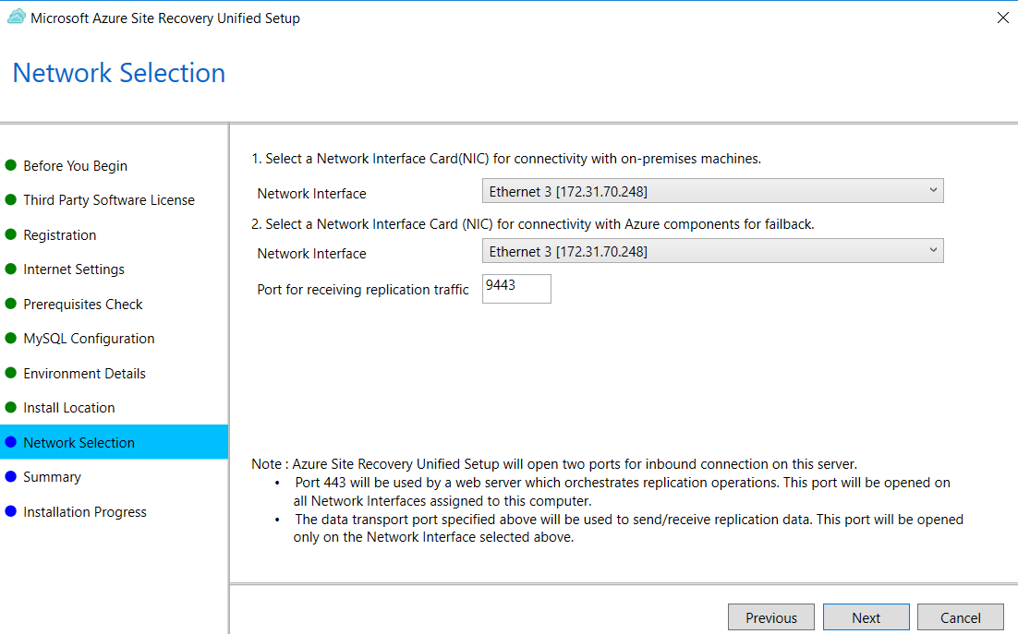
Step 11: Now install all the prerequisites. It could take 15-20 mins to install.
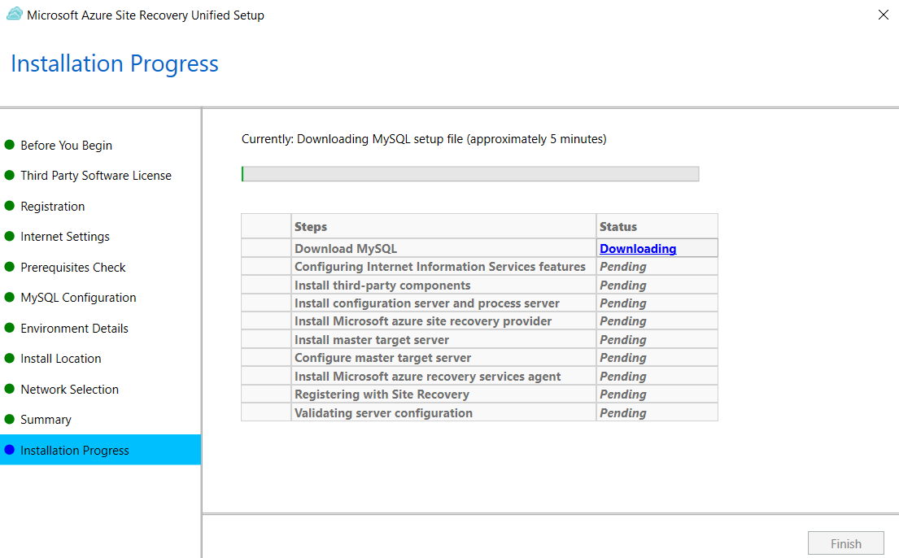

Step 12: After completion of the installation, it will prompt to copy the passphrase. Copy it and paste it in notepad. (Note: passphrase is required to register the agent to replication server.)
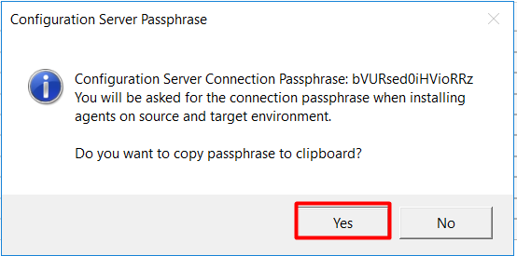
Step 13: Now Add the account on azure site recovery.
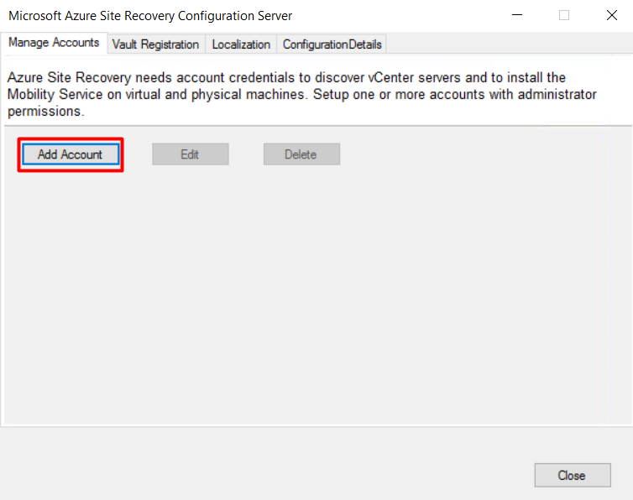
Step 14: Now add the vault Registration as same file as registration key. Registration could take 5-10 mins.
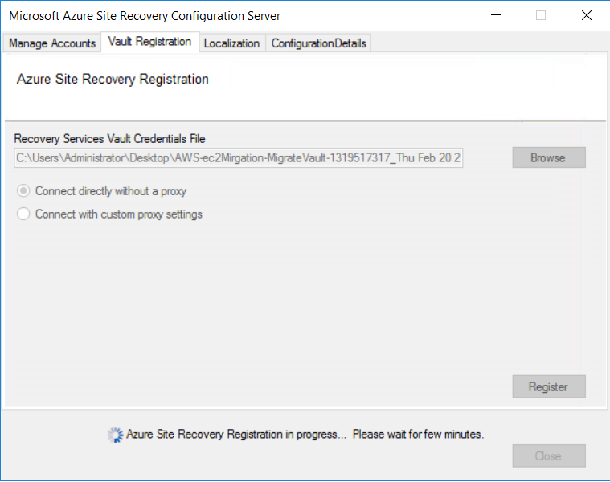
Step 15: Now navigate to Local drive C, then look for hidden folder ProgramData
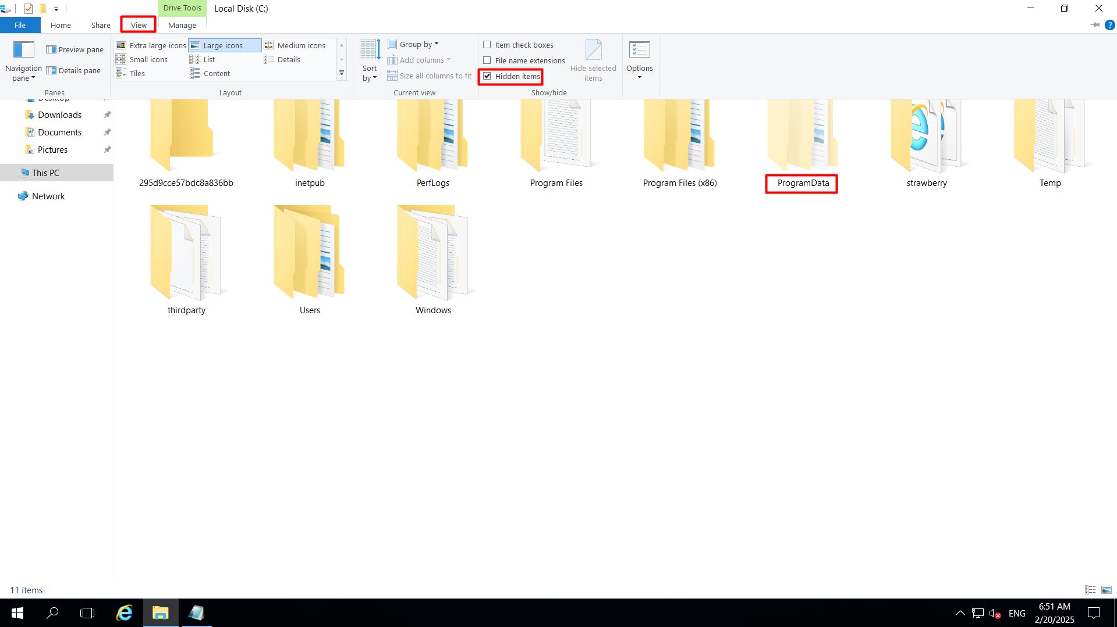
Step 16: Now Navigate to the location for replication agent C:\ProgramData\ASR\home\svsystems\pushinstallsvc\repository
Copy that agent and paste it in the source server.
The best way is to use internet to transfer the agent.
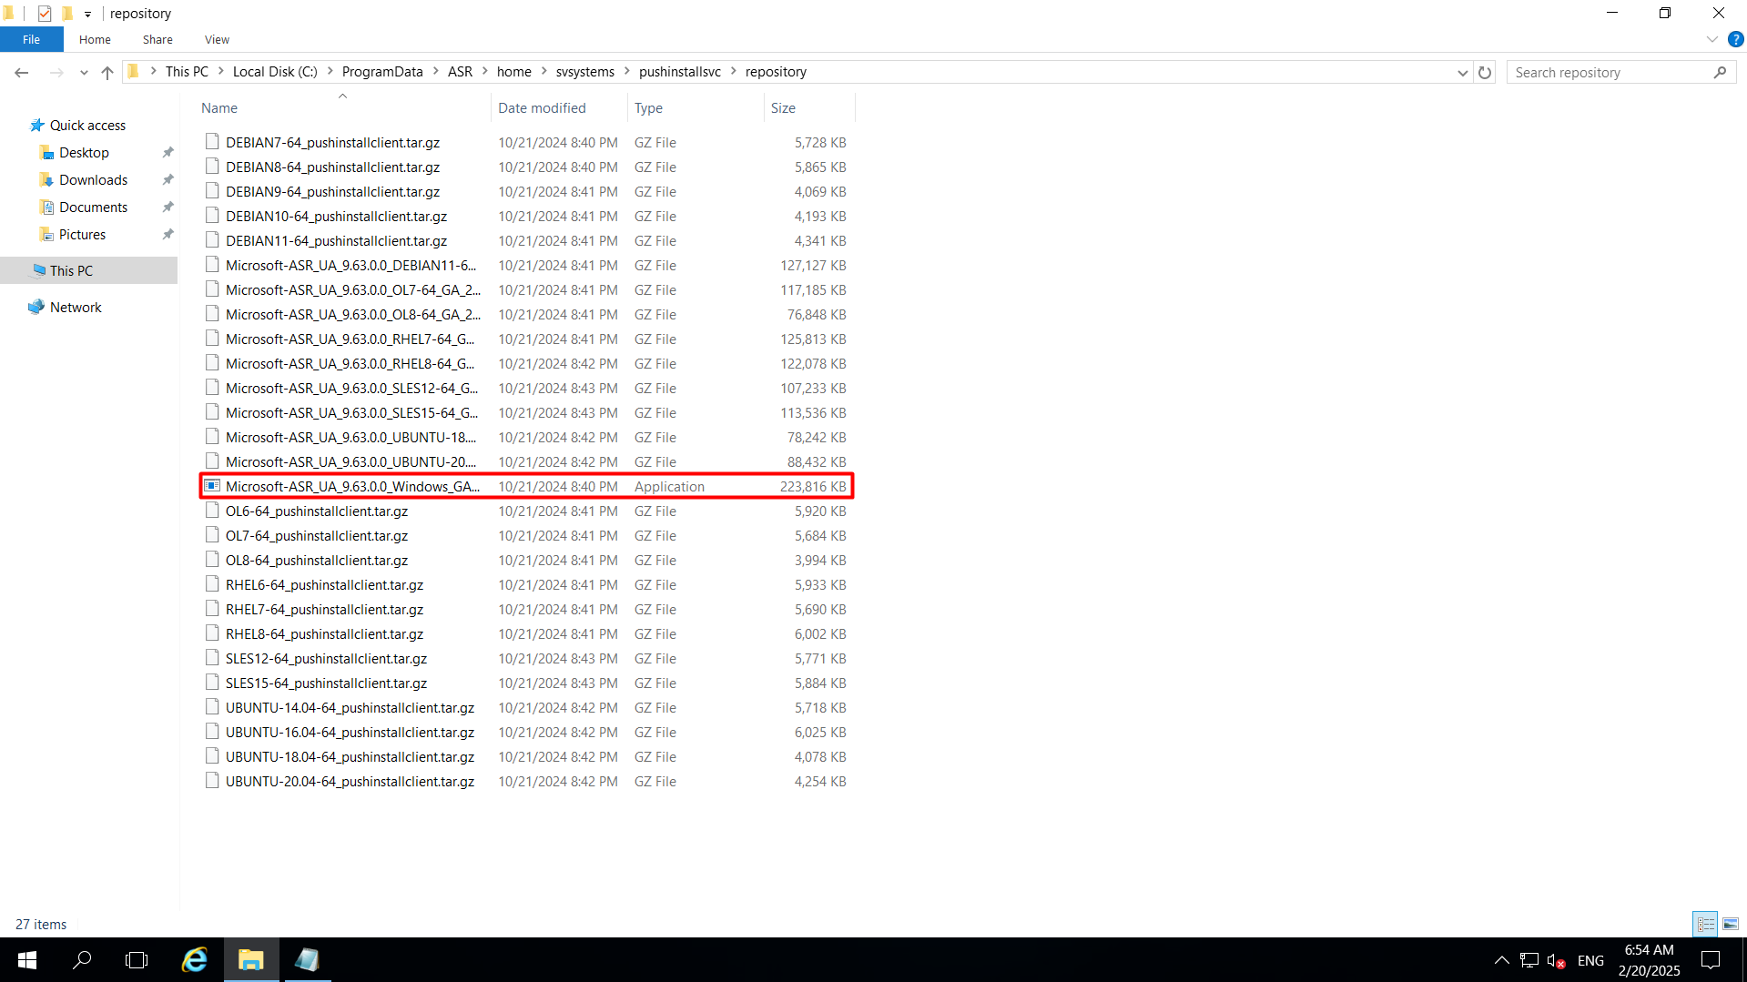
Step 17: After the installation of the Azure Site Recovery Unified Agent. We have to configure the mobility agent. I highly recommend to use older version for mobility agent as the newer version got some issue.
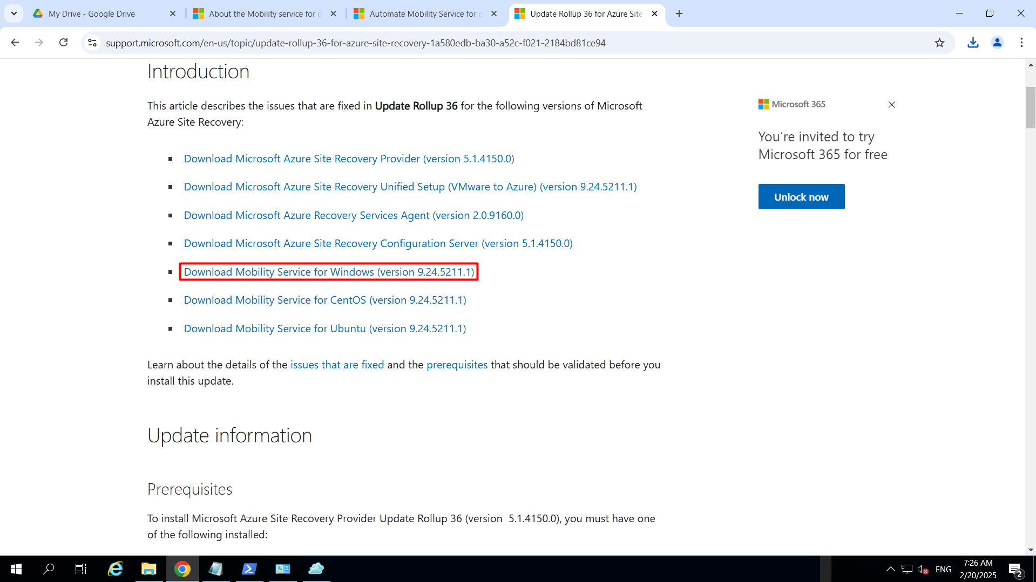
Step 18: Install the mobility Agent.
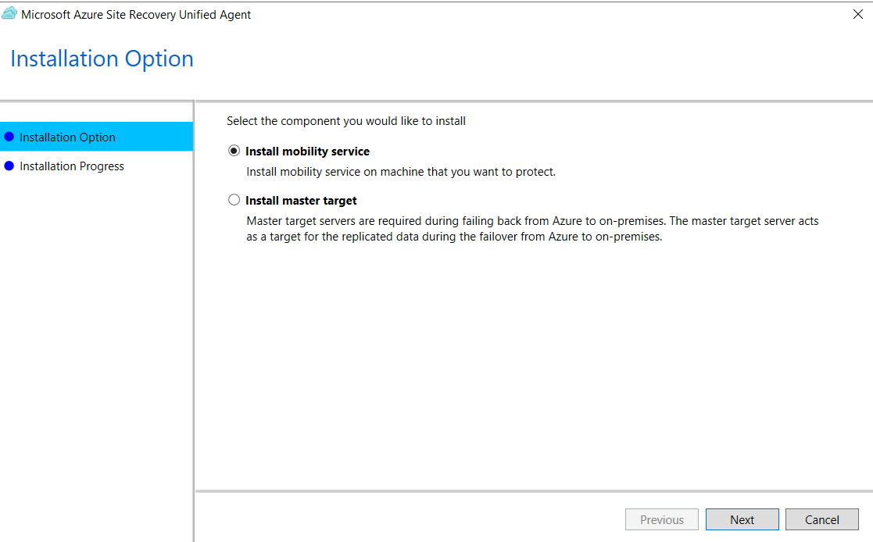
Step 19: After the installation of mobility service, Configure the agent.
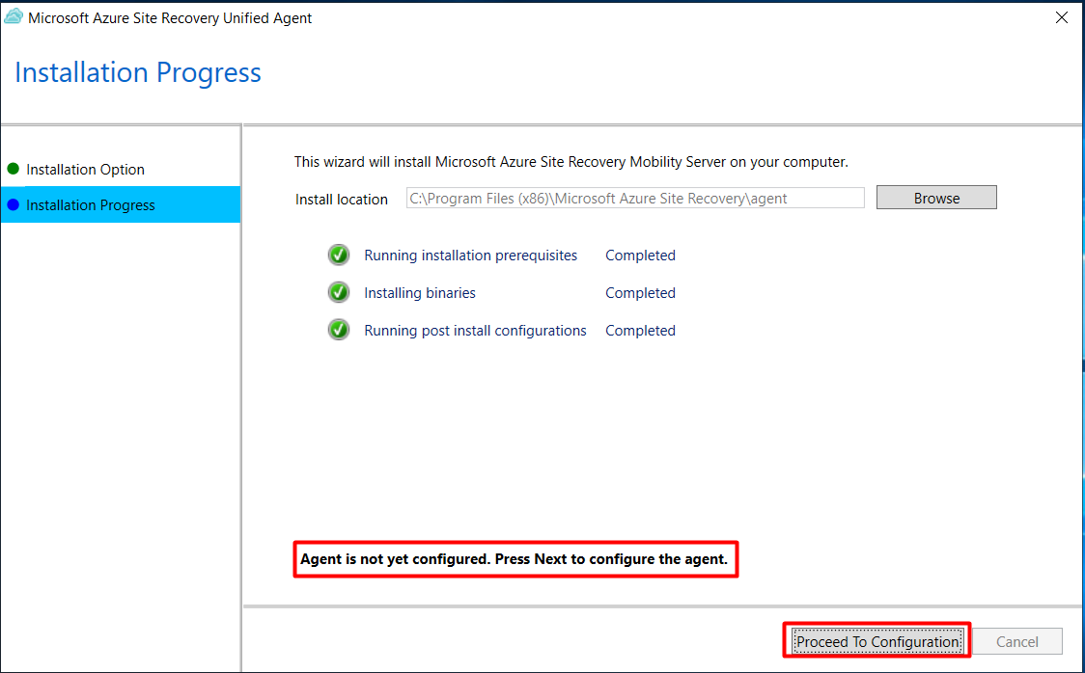
Step 20: before Installation of agent, you should open the HTTPS port for the agent to connection with replication server or you might see this error.
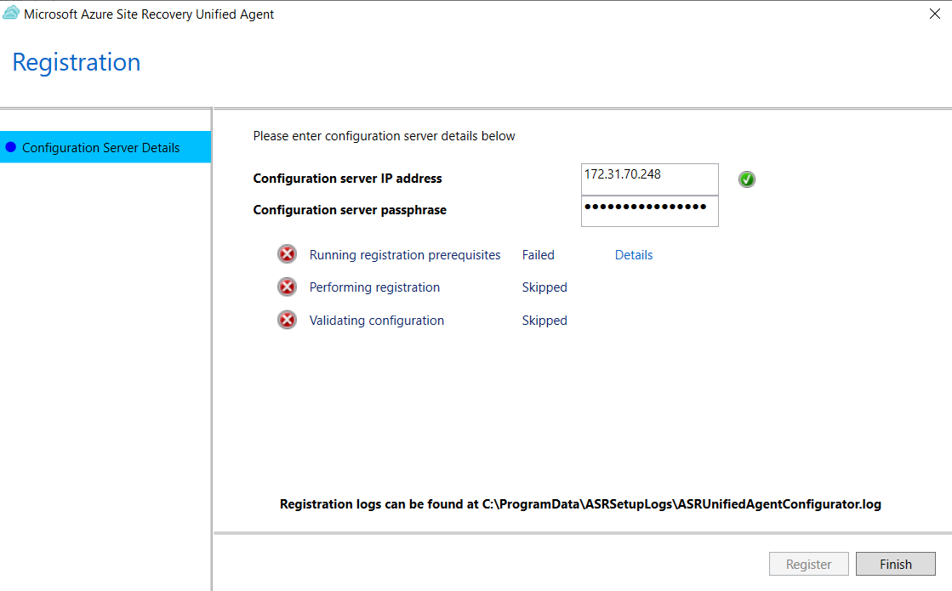

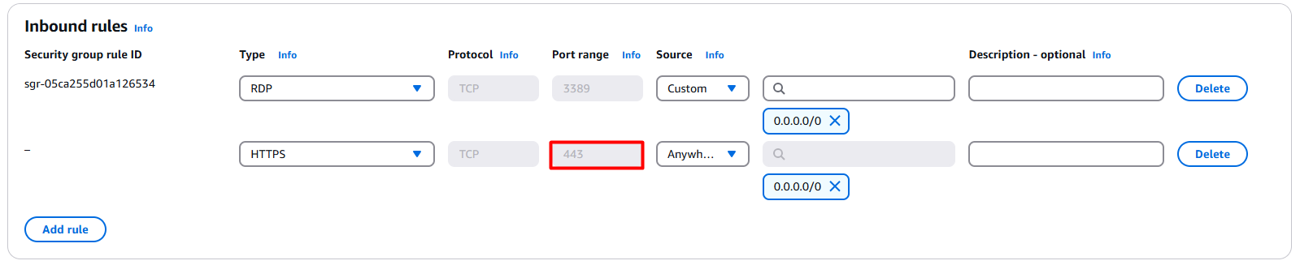
This is how it looks after completing the installation. Then restart the server to complete perfect agent installation.
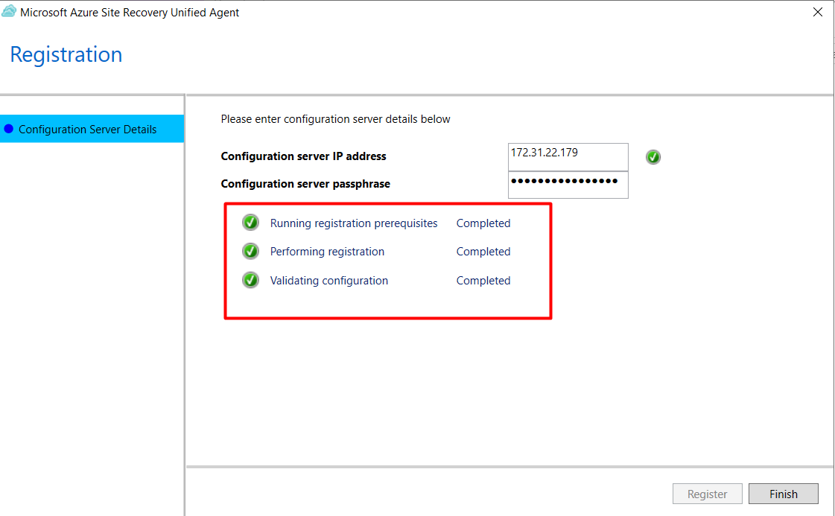
Step 21: Now check the azure portal, that configuration server is available for finalize registration.
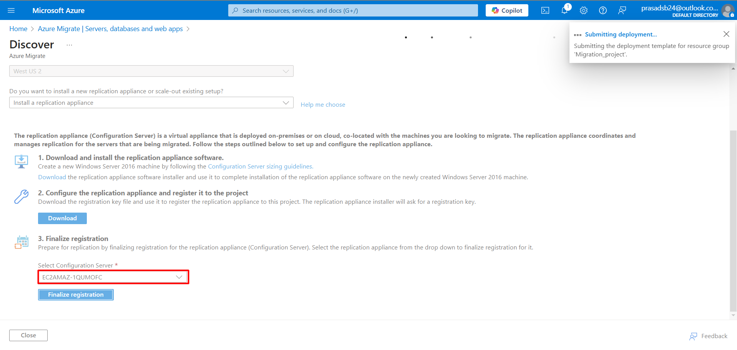
Step 22: Now click on replicate icon to move to the next step.
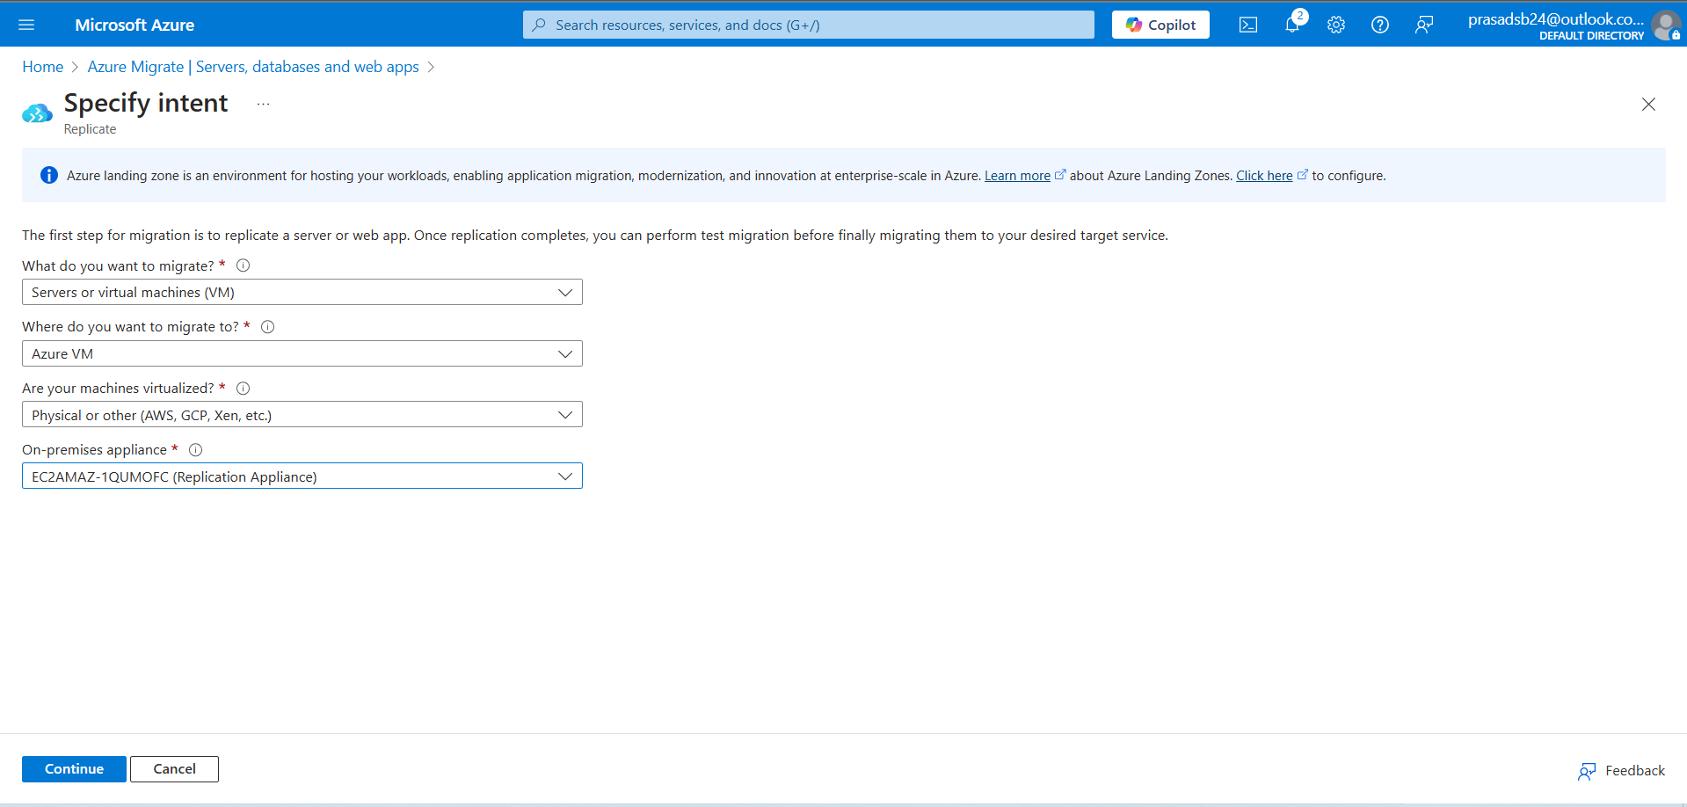
Step 23: Select the basics.
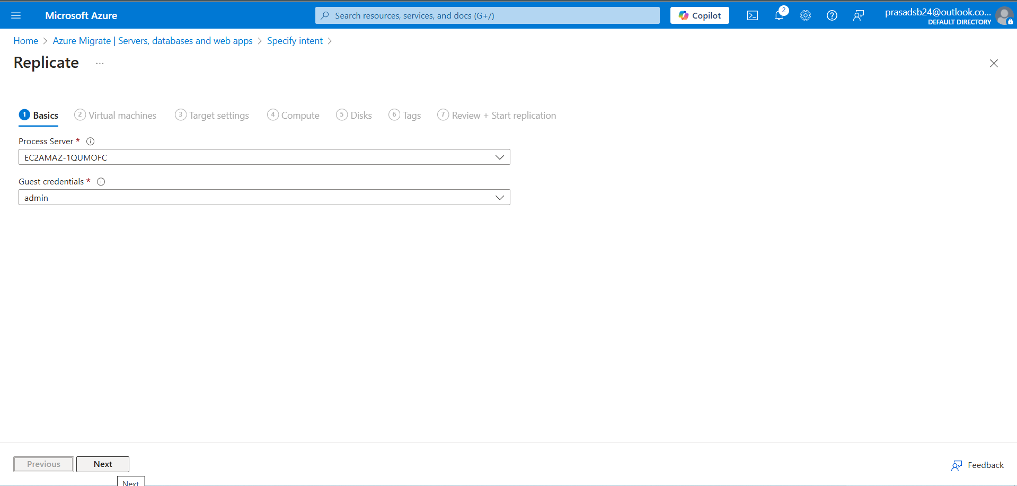
Step 24: select the target server.
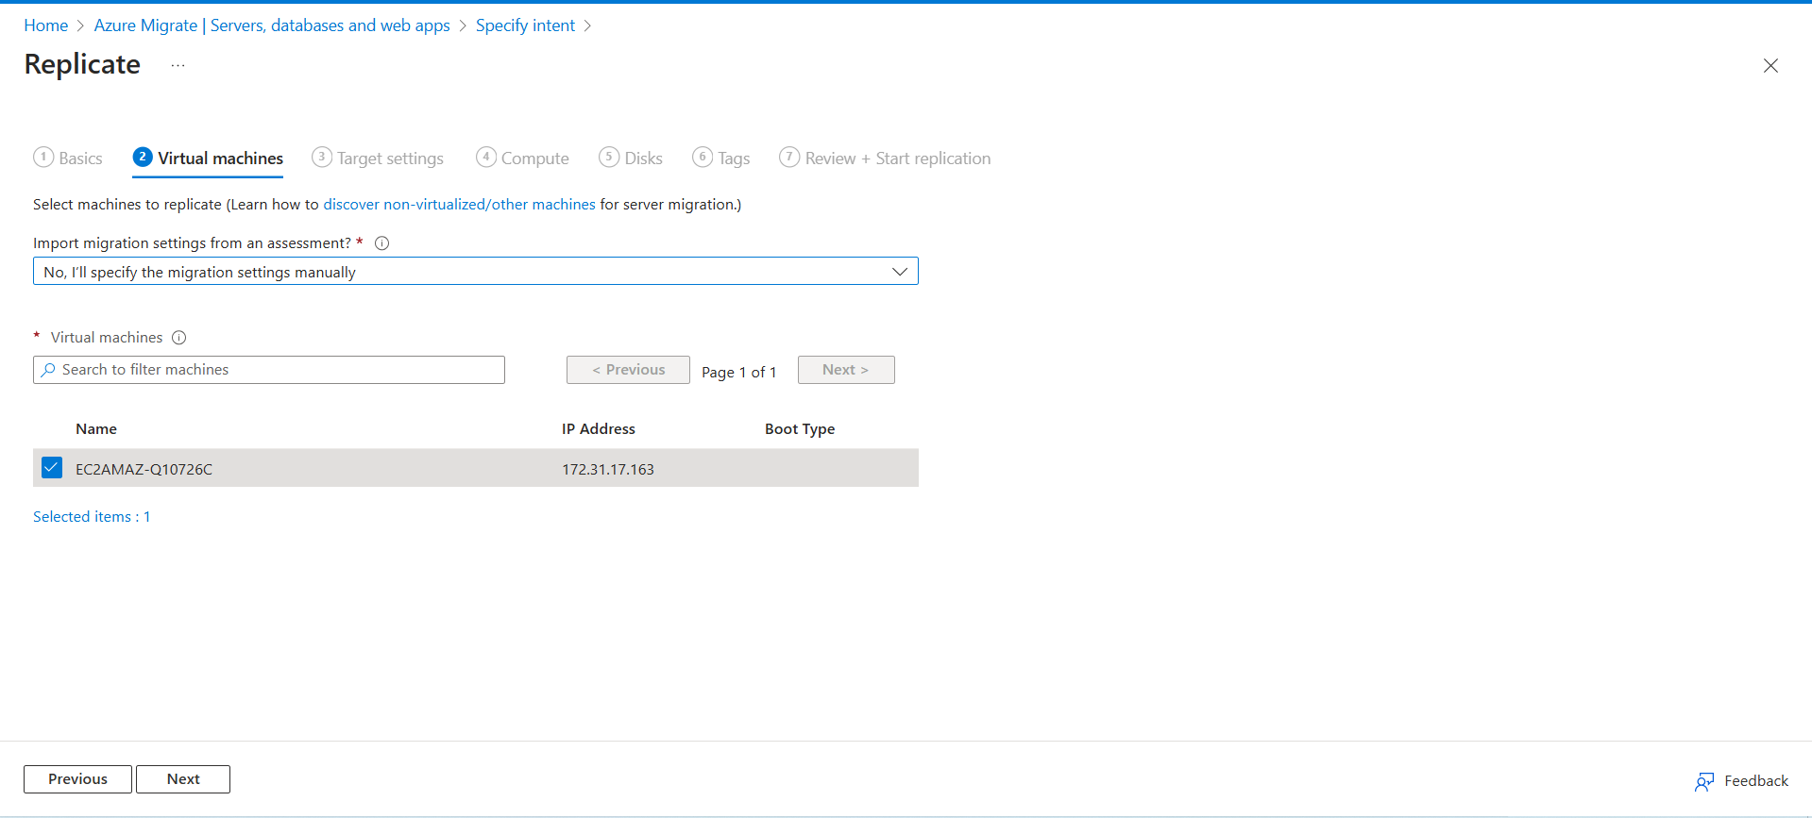
Step 25: Select own target setting (note: Create Vnet and subnet first to attach to replication)

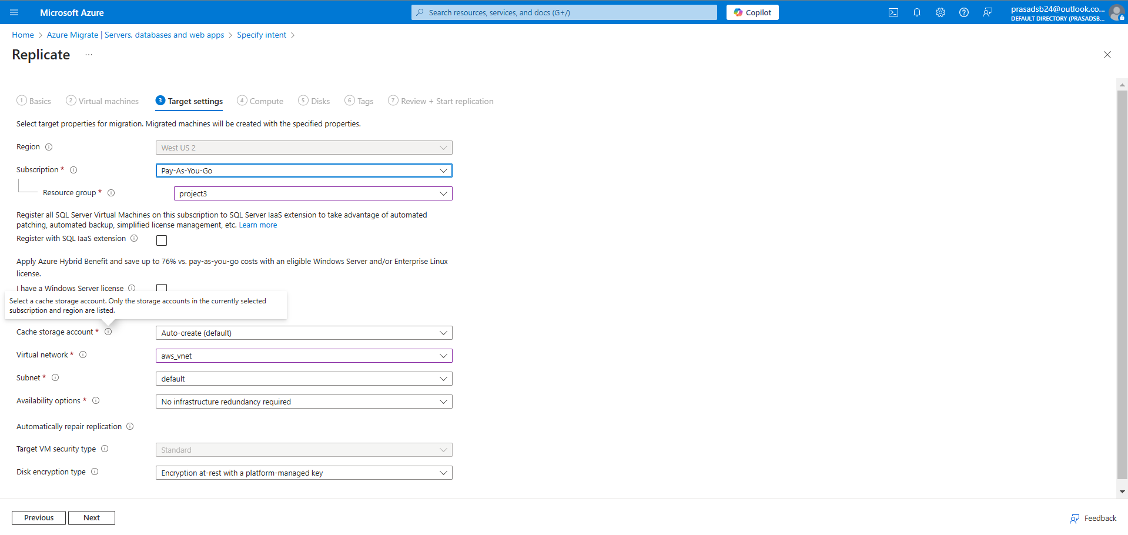
Step 26: Select the Compute VM size or keep it default.
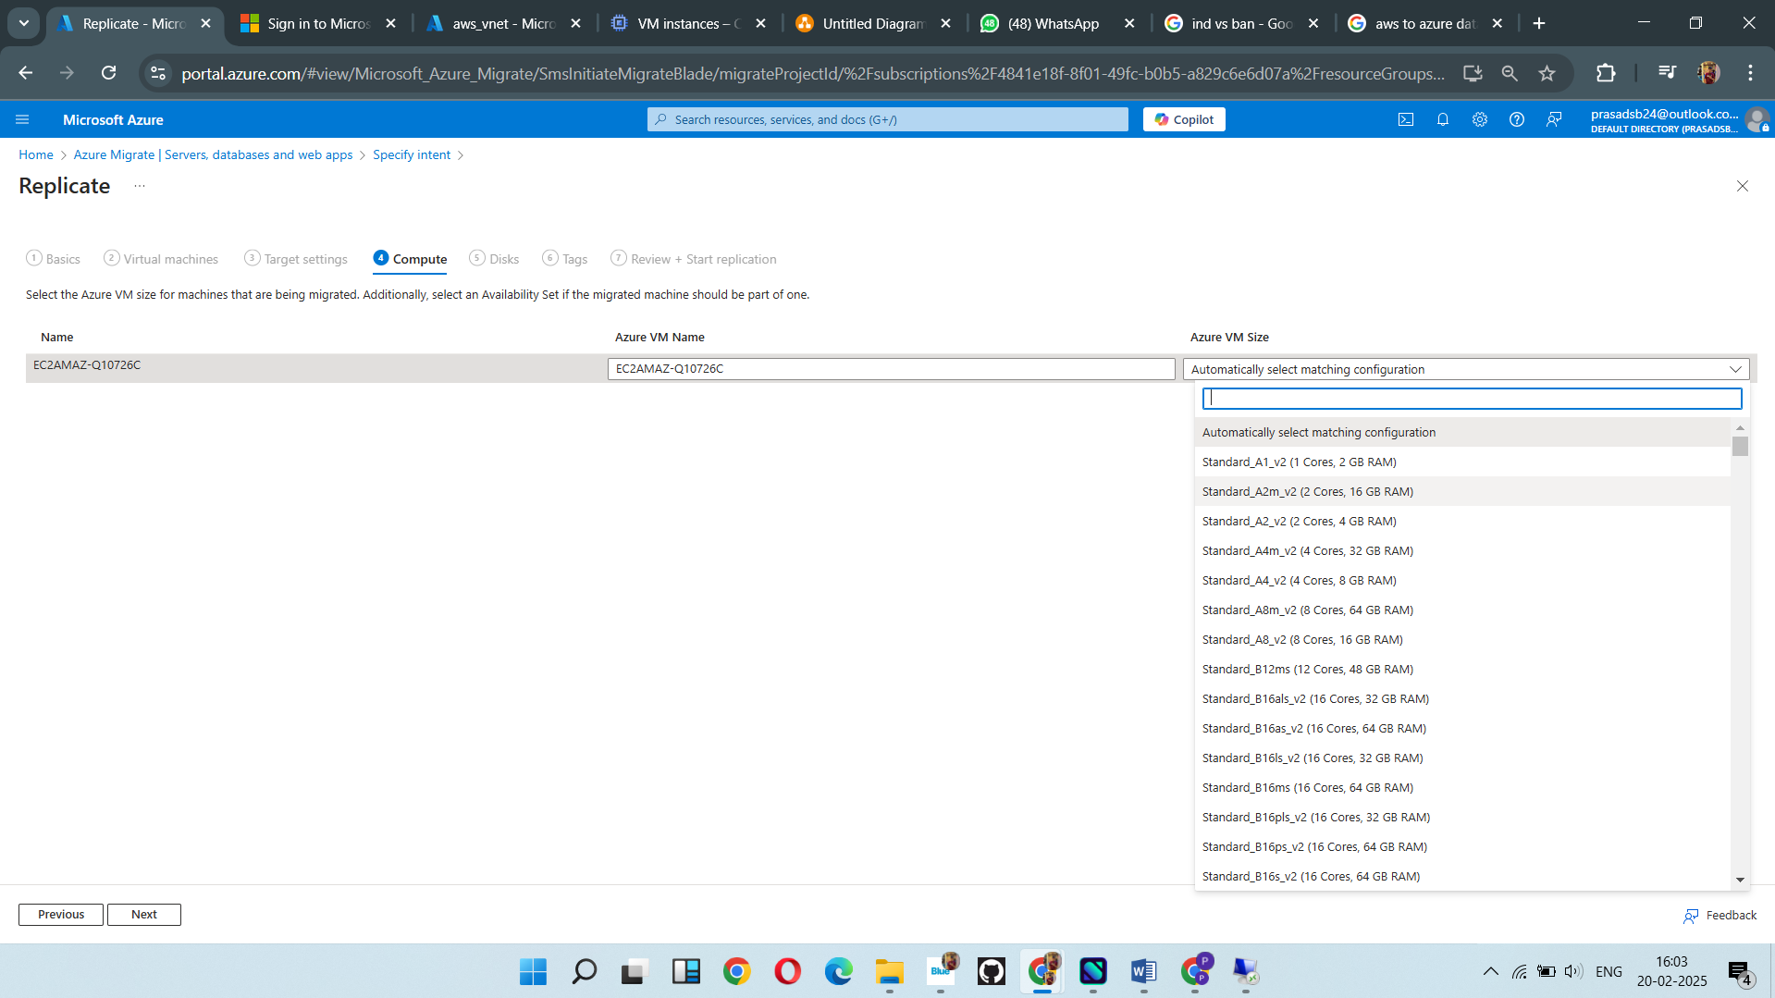
Step 27: Select the disk type.
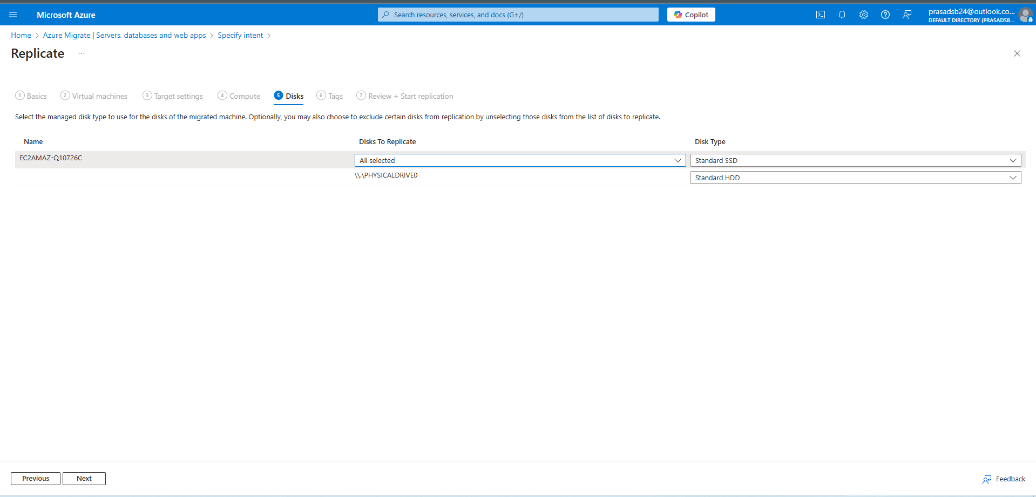
And start the replication.
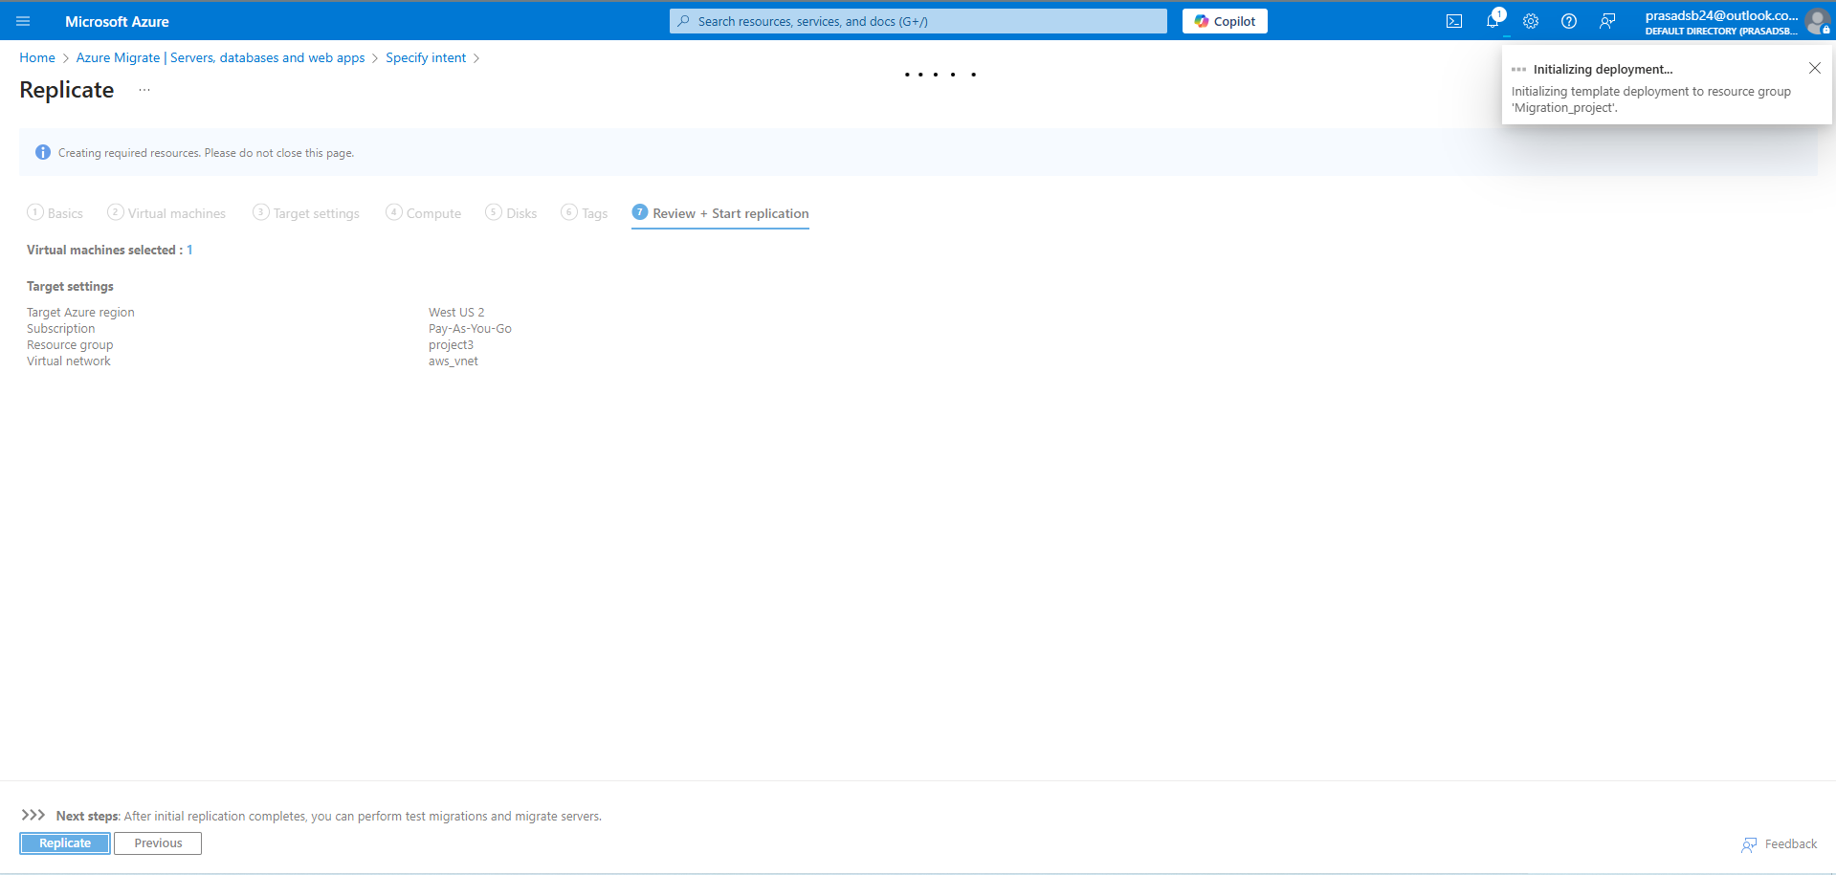
Here is the status of replication
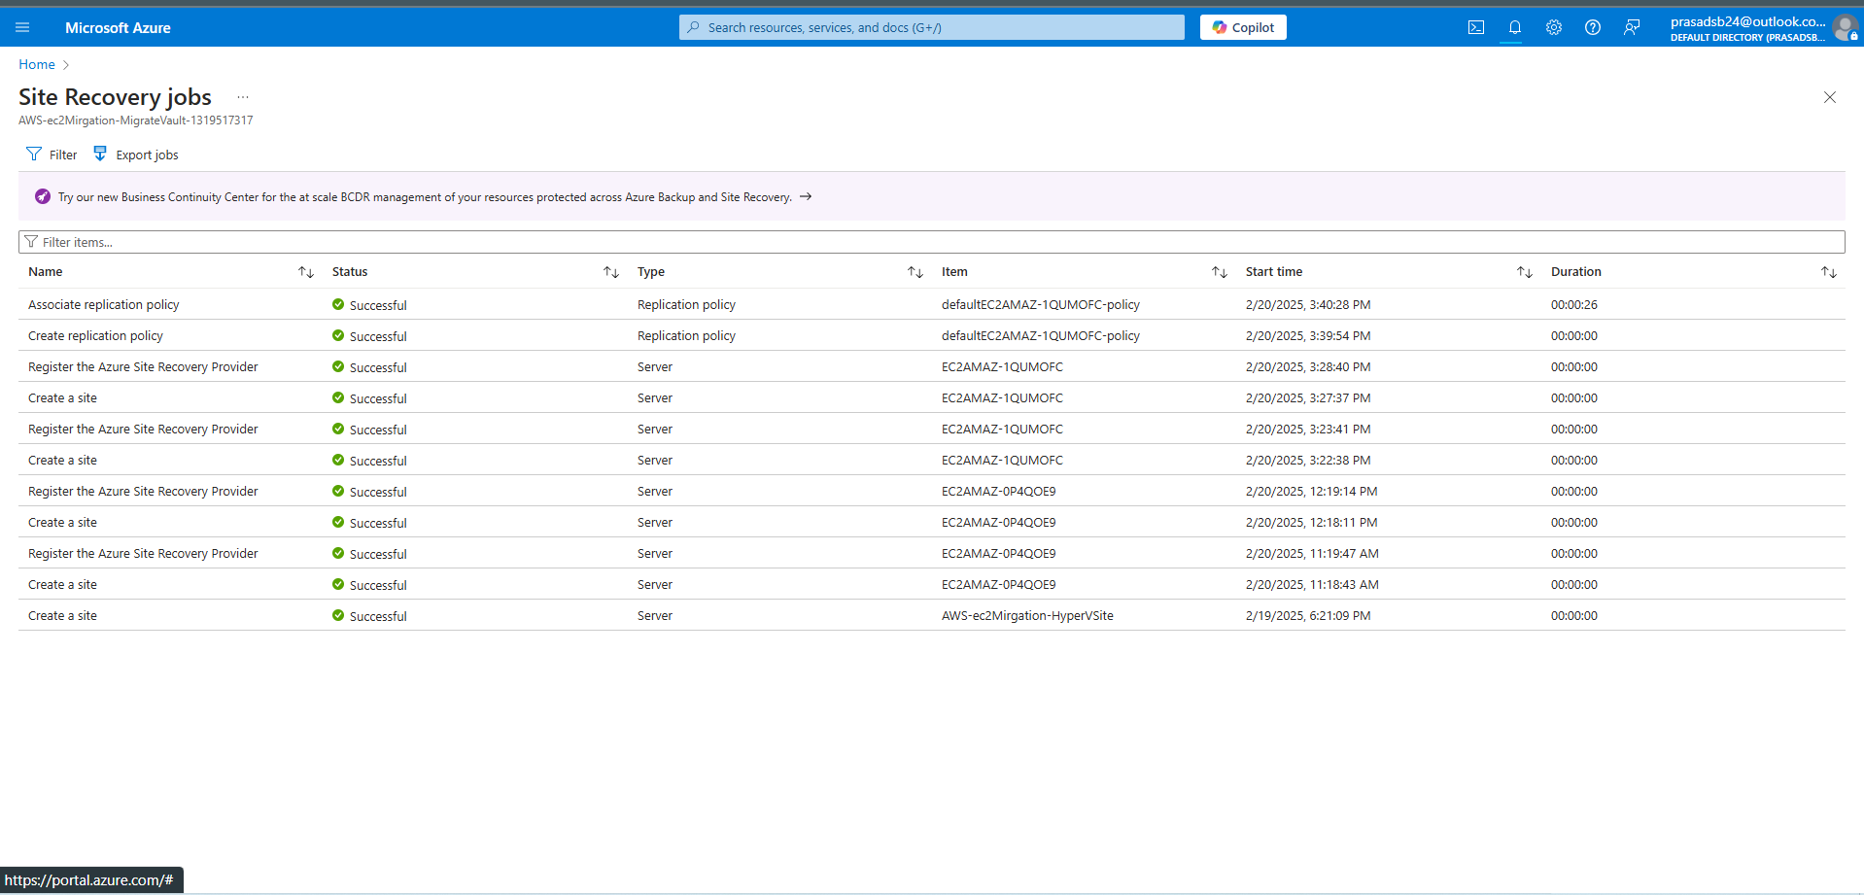
Step 28 : look for the Replication in migration Dashboard.
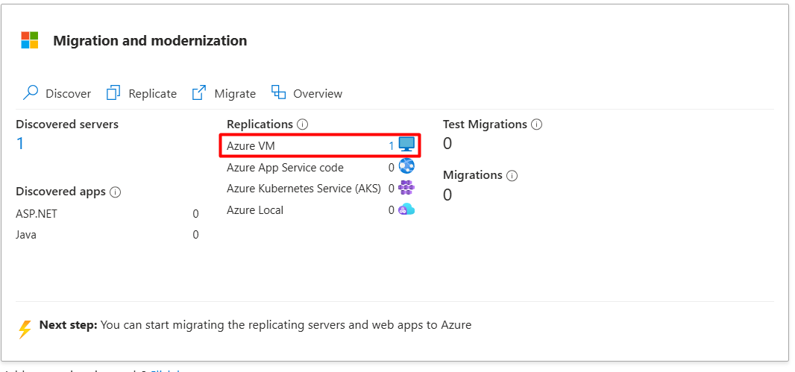
Here is one error regrading older version agent.
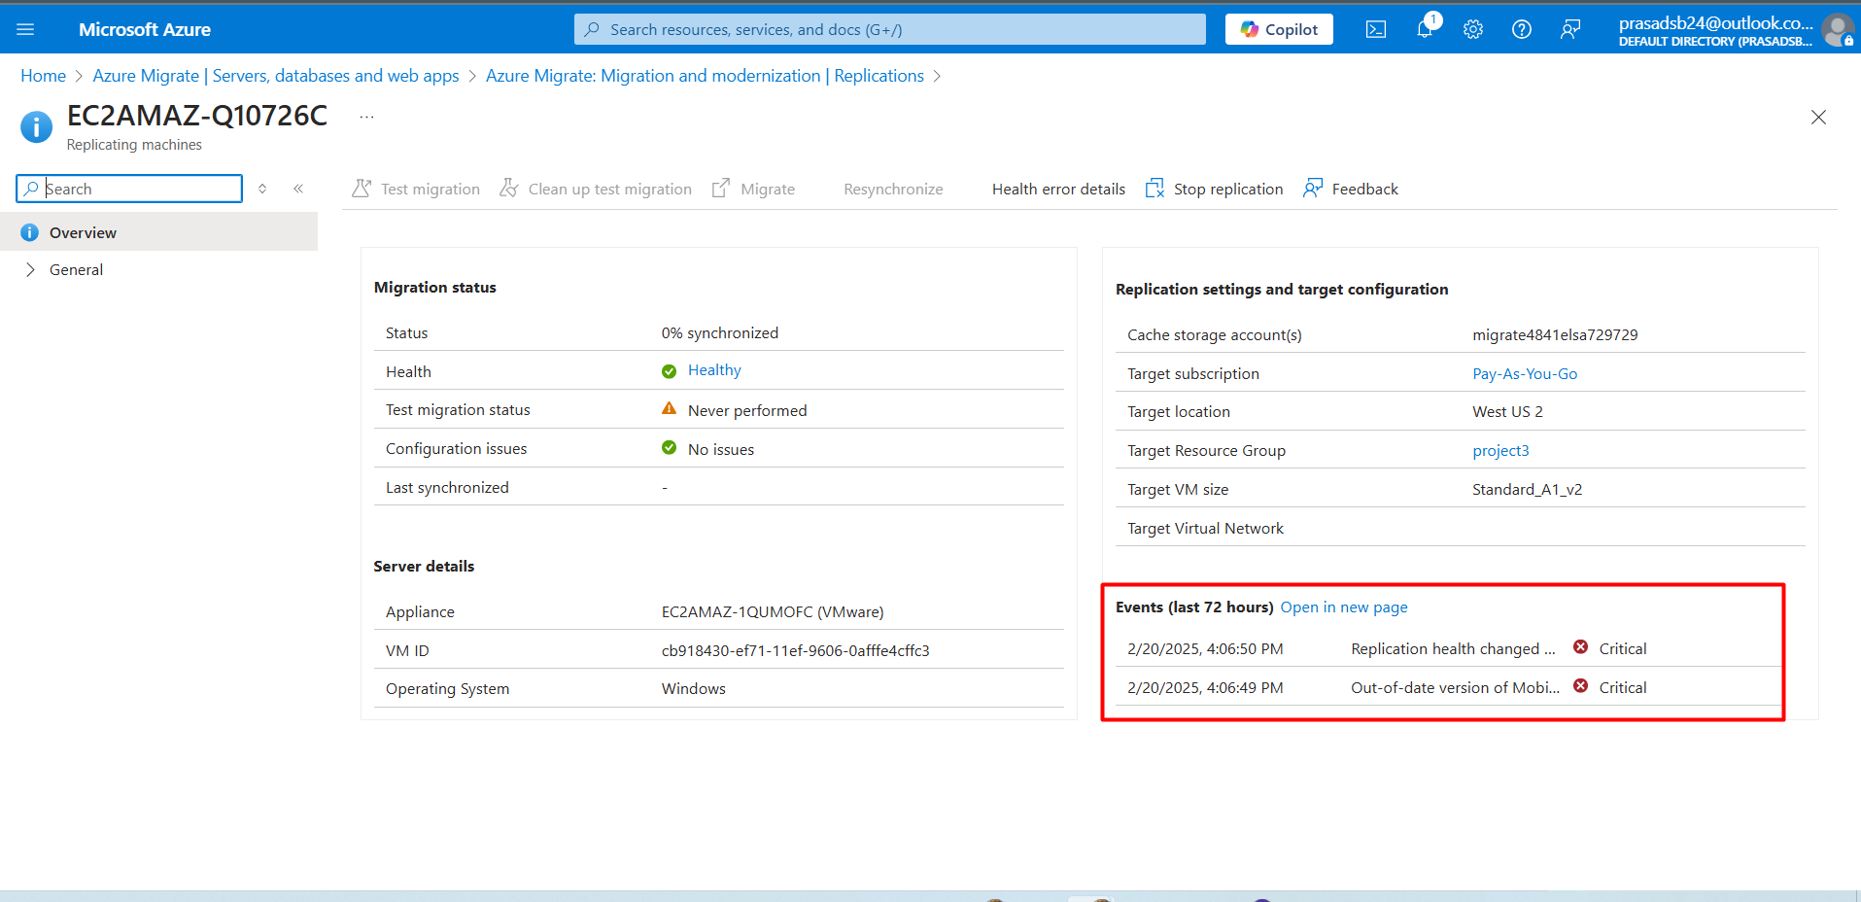
To fix this error just upgrade the agent in your server.
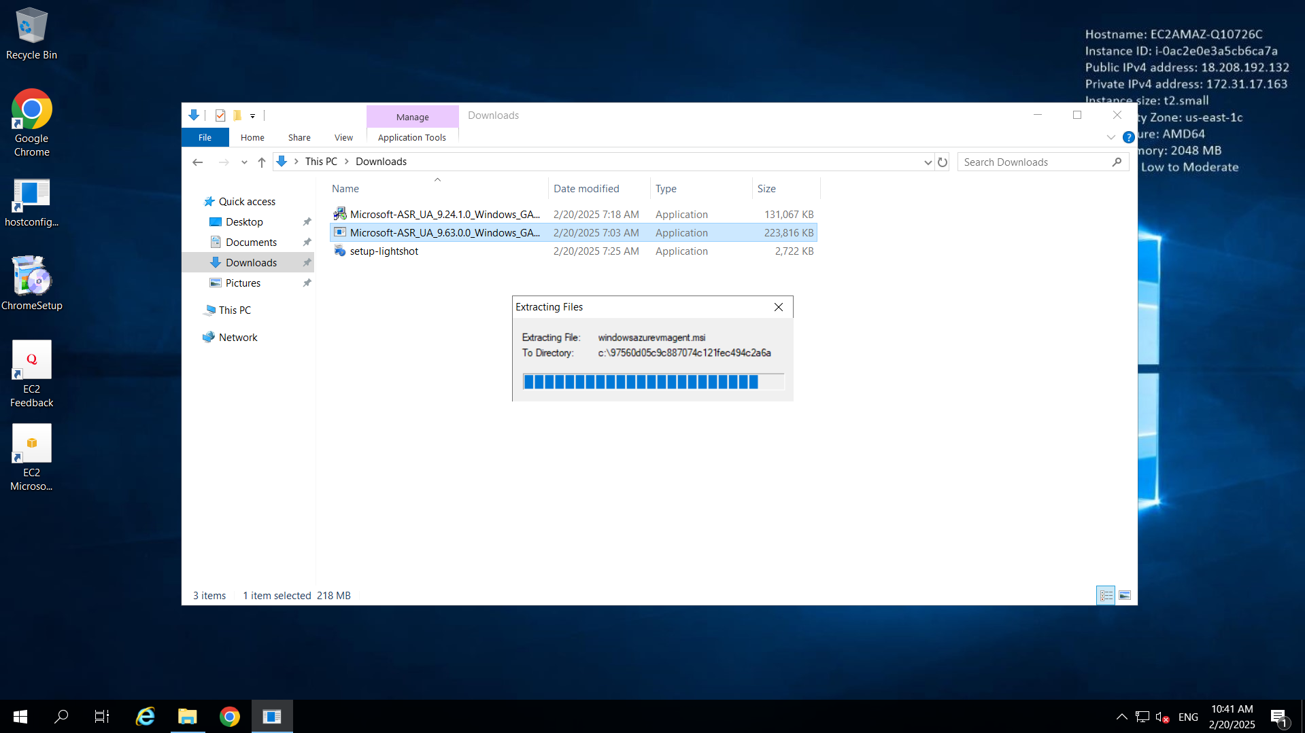
It will show that agent is updated!!!.
